- Company
- Site
- Inventory Locations
- Customer
- Supplier
- Inventory Part
- Purchase Part
- Sales Part
- Supplier for purchase part

Company
- Copy all data on Company page

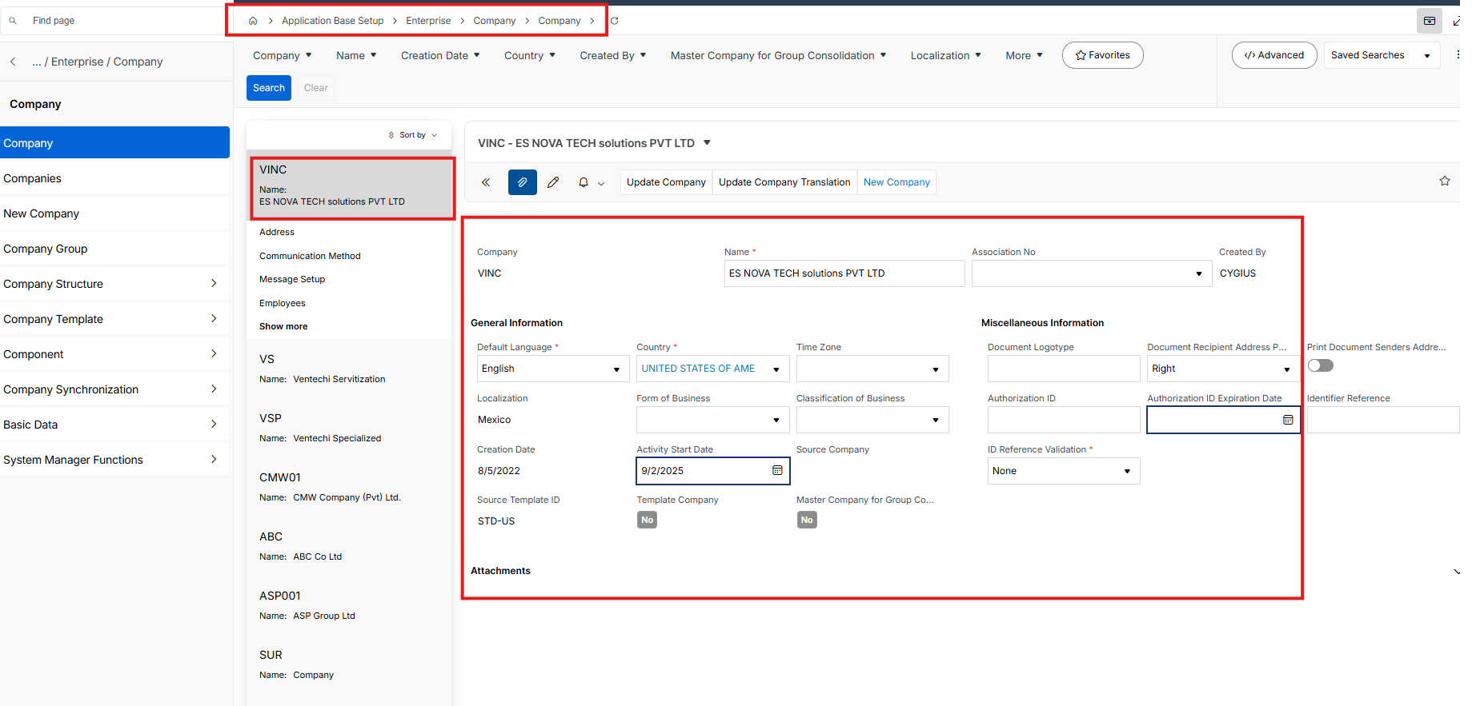

- Coppy address Address tab details

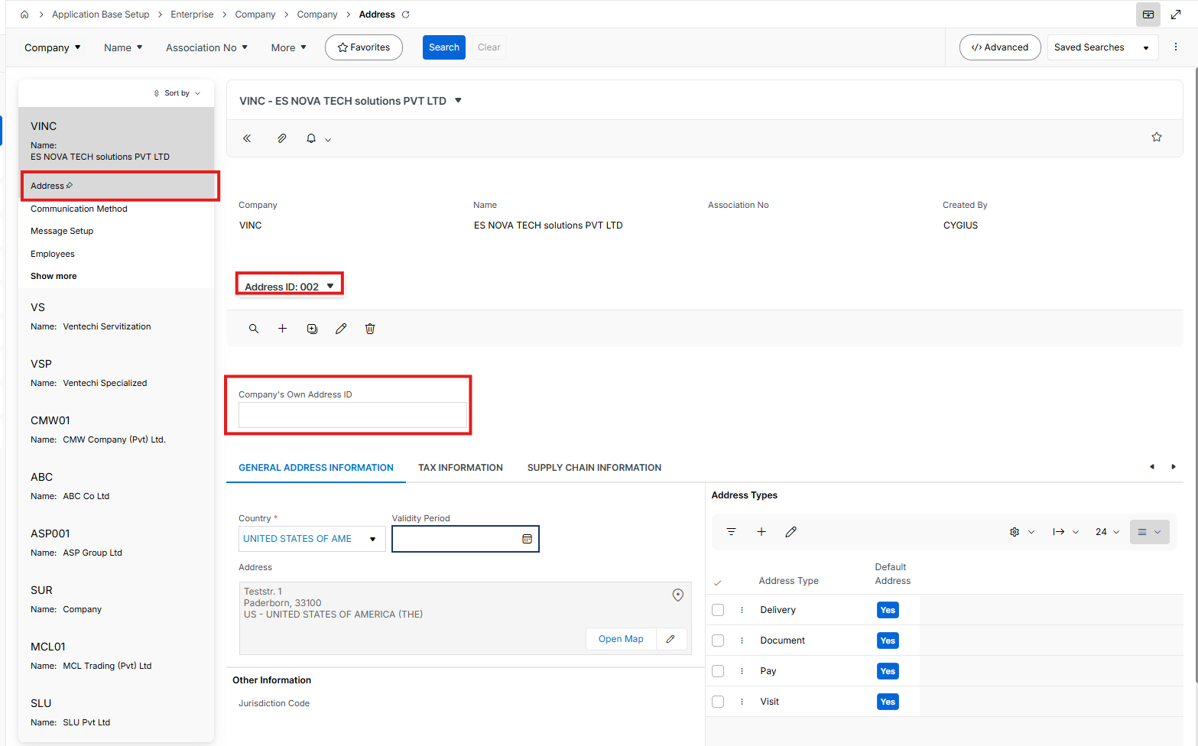

- Copy all General Address Information sub-tab details

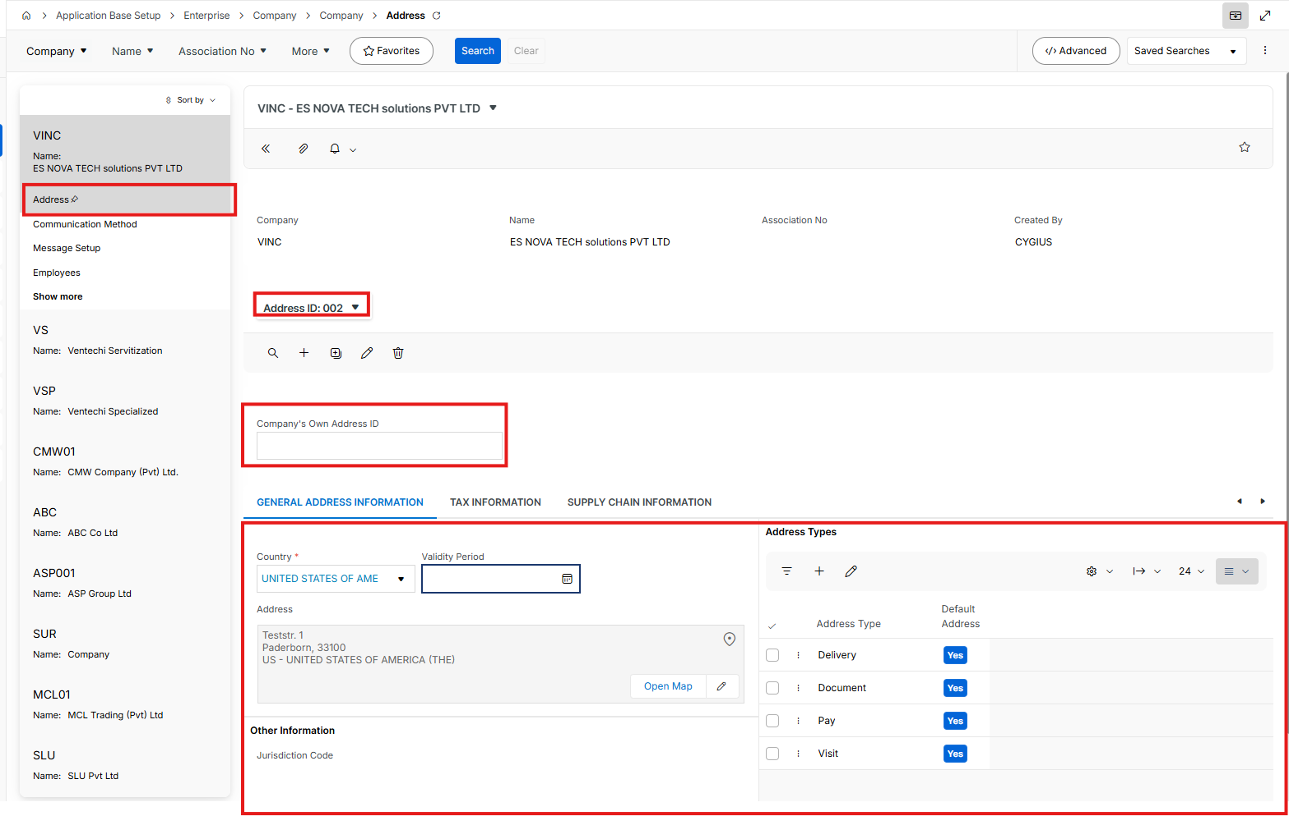
- Copy all Tax information sub-tab details

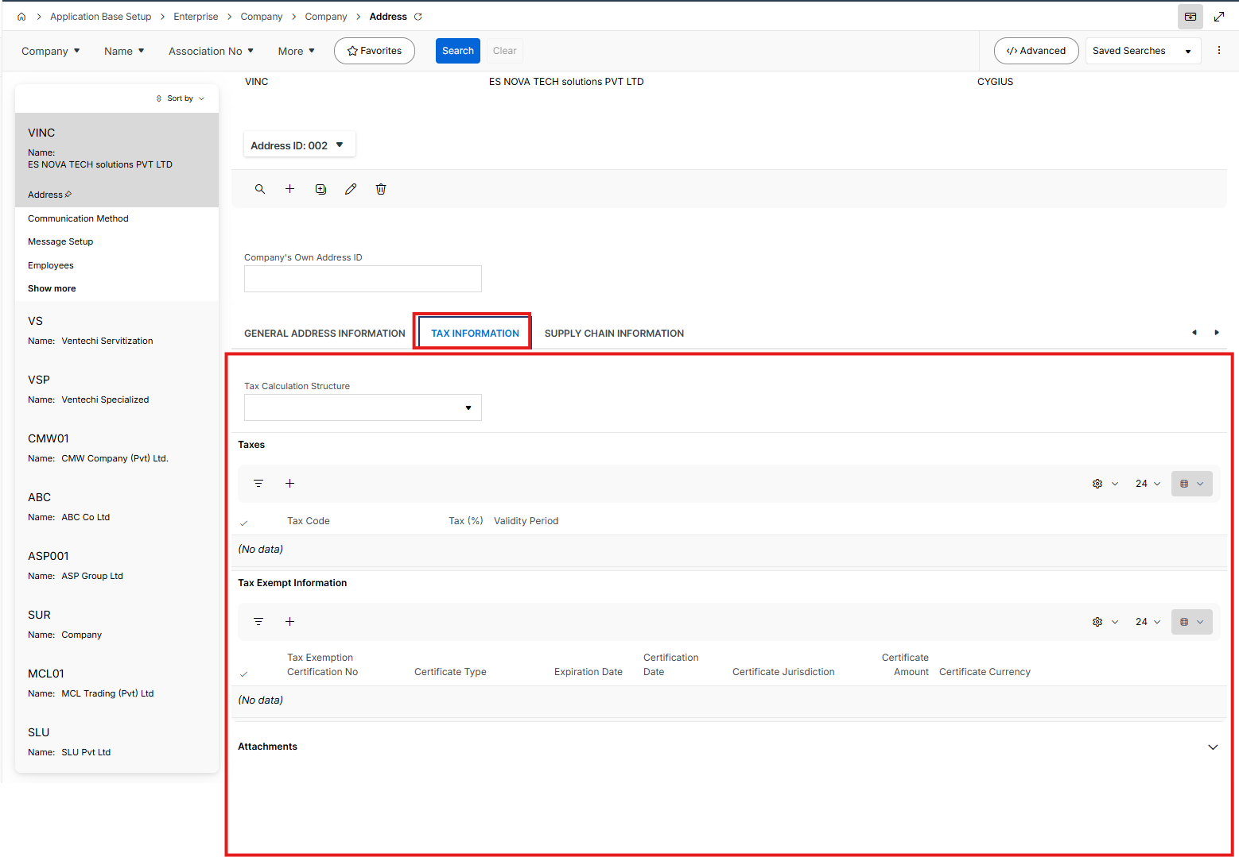
- Copy all Supply Chain Information sub-tab details

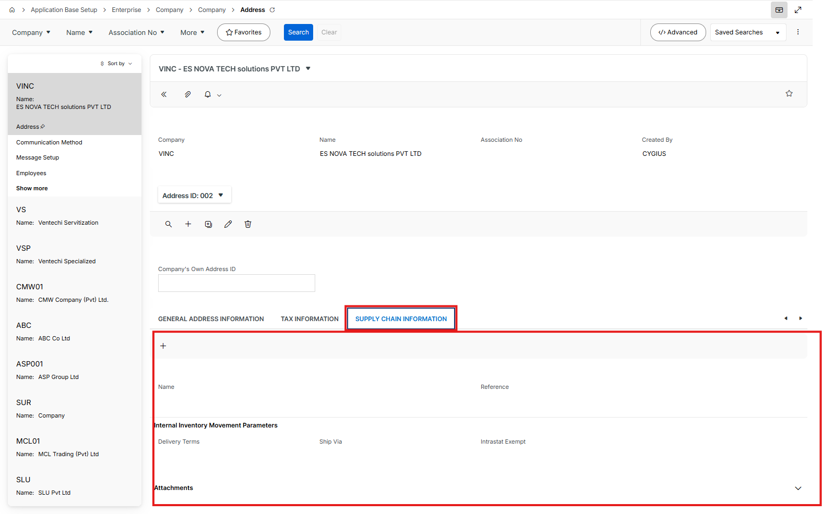

- Copy all Communication Method data

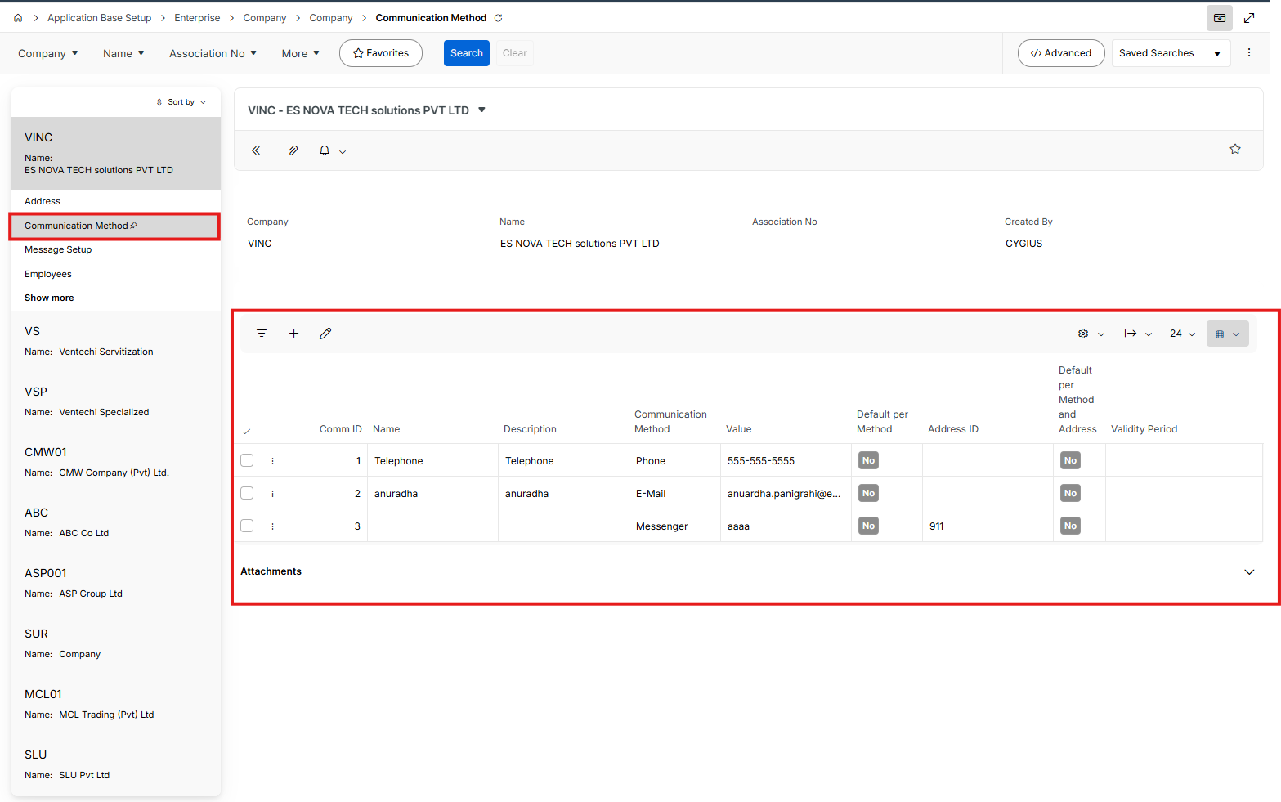

- Copy all Message Setup data

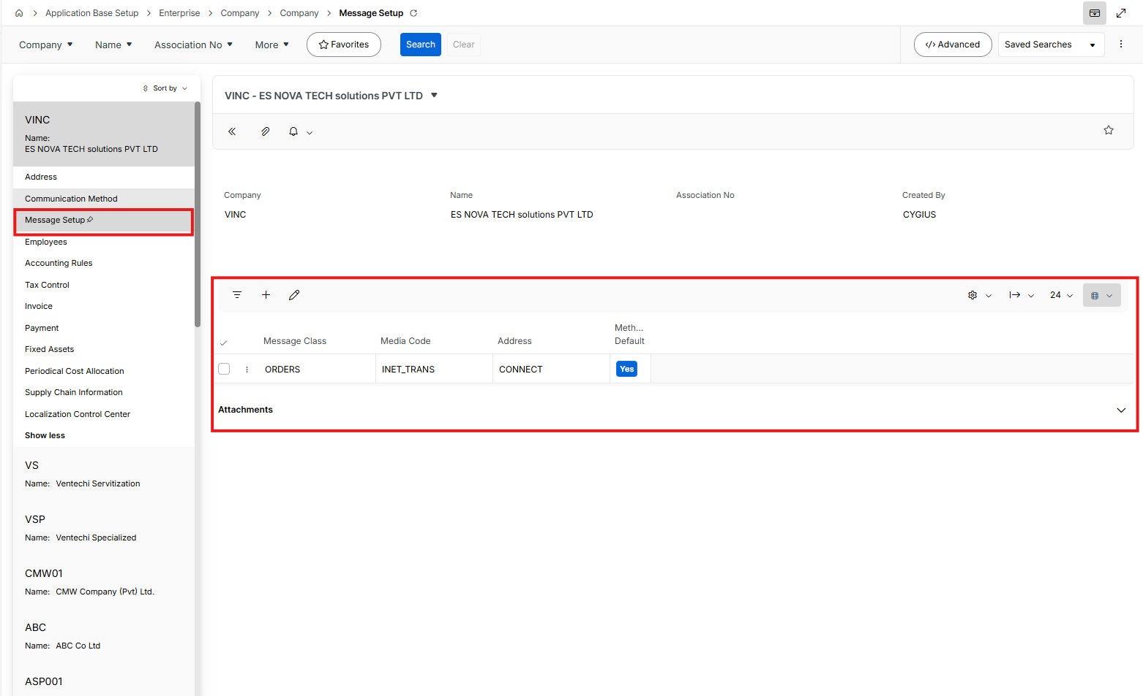

- Copy all Employees data

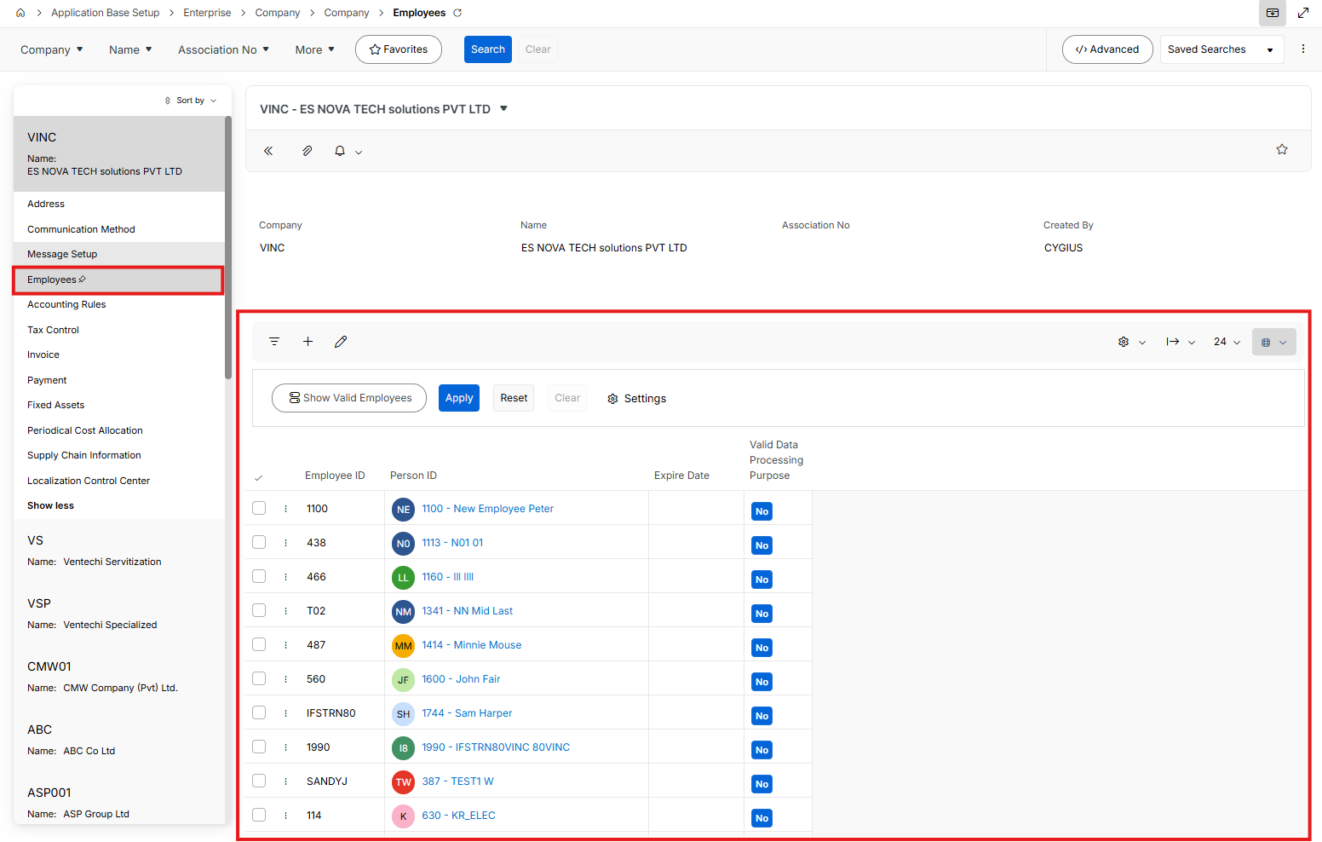

- Copy all Accounting Rules data on both tabs
  - General Data sub-tab

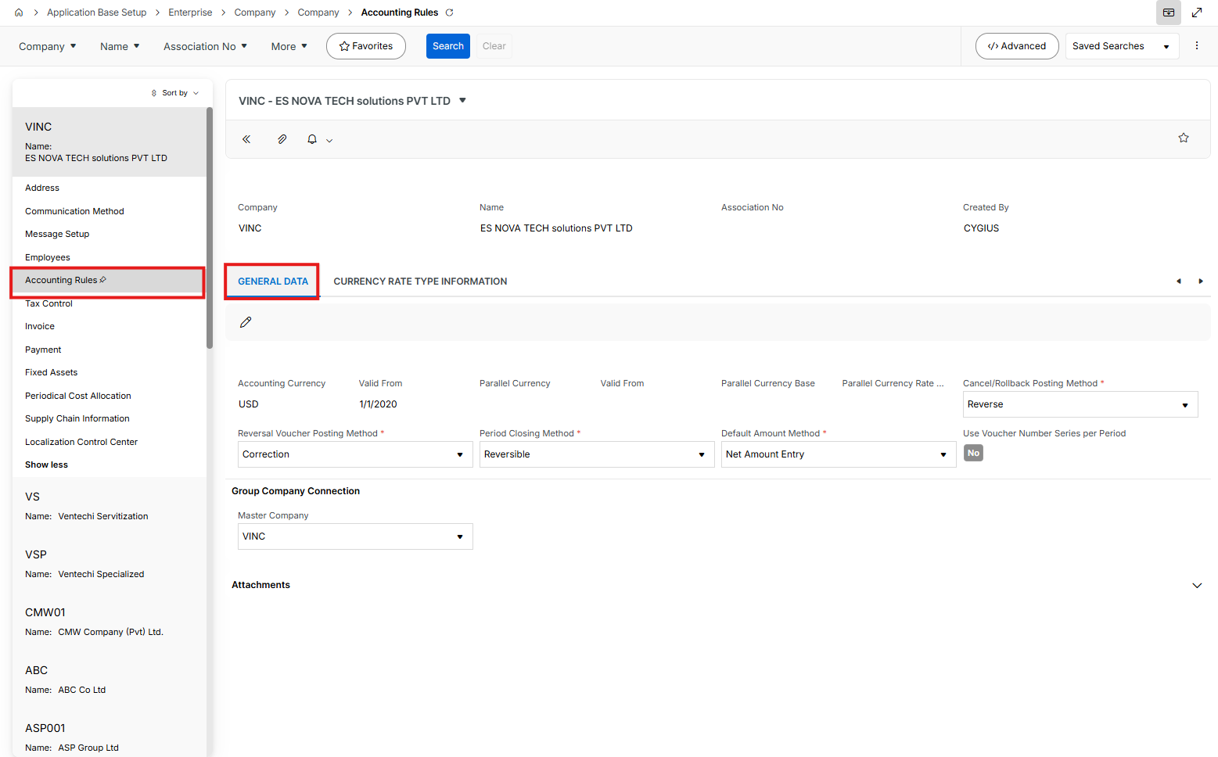

  - Currency Rate Type Information sub-tab

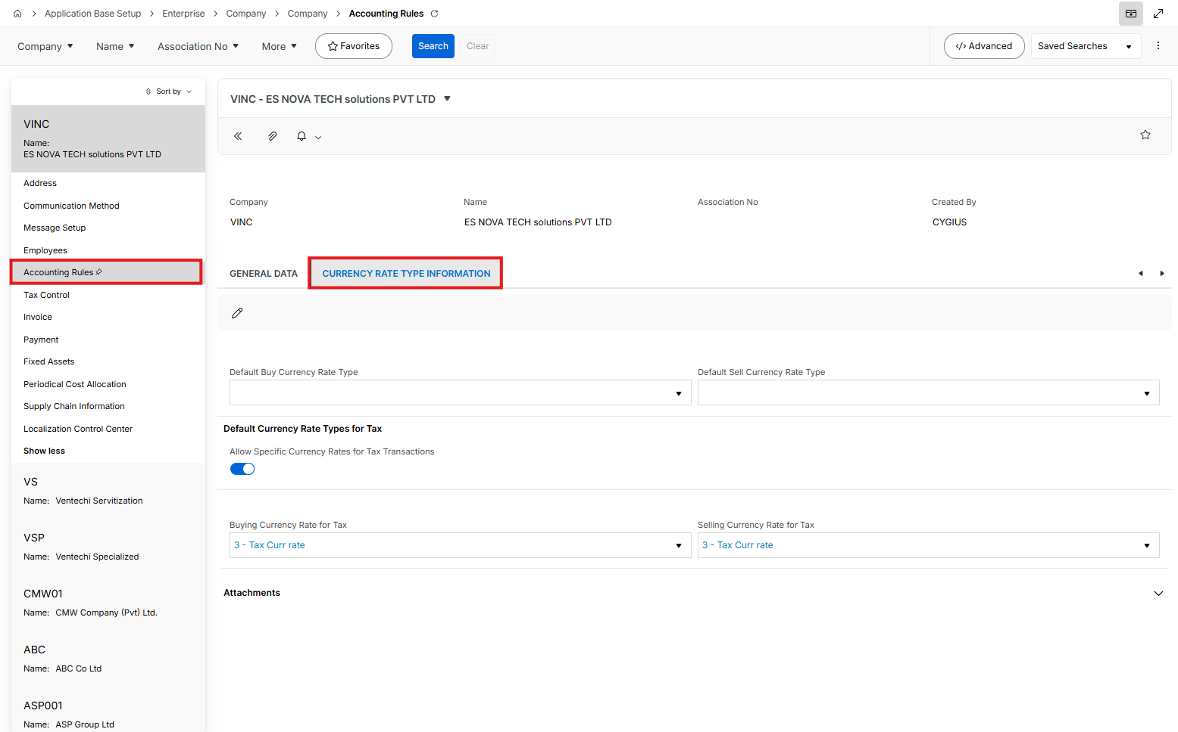

- Copy Tax Control data on 4 tabs
  - General Sub tab

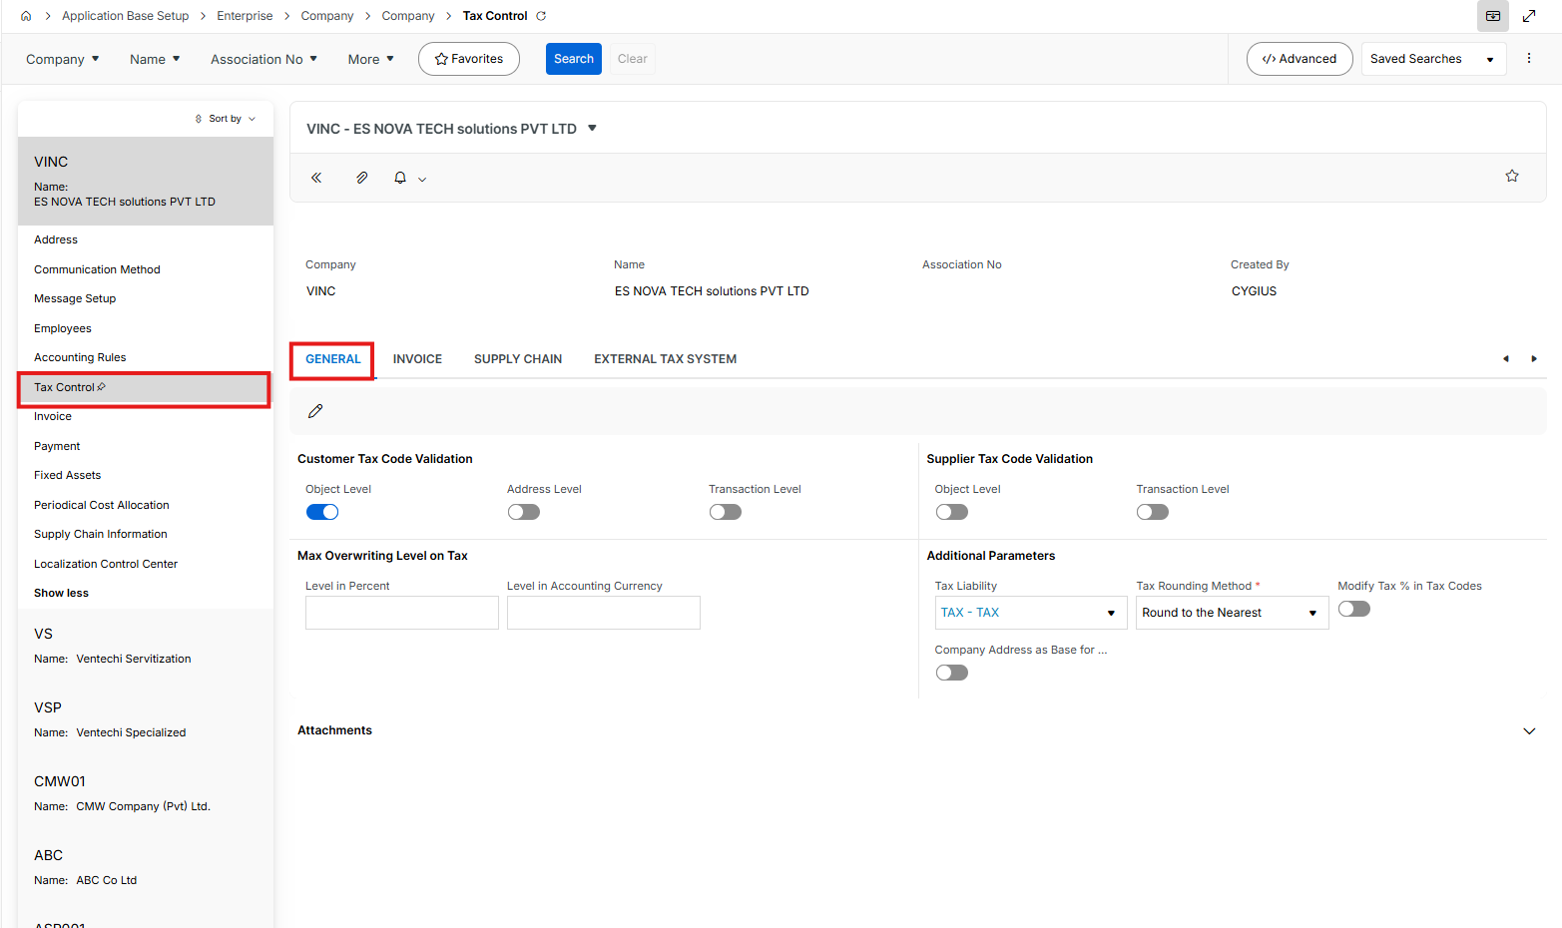

  - Invoice sub-tab

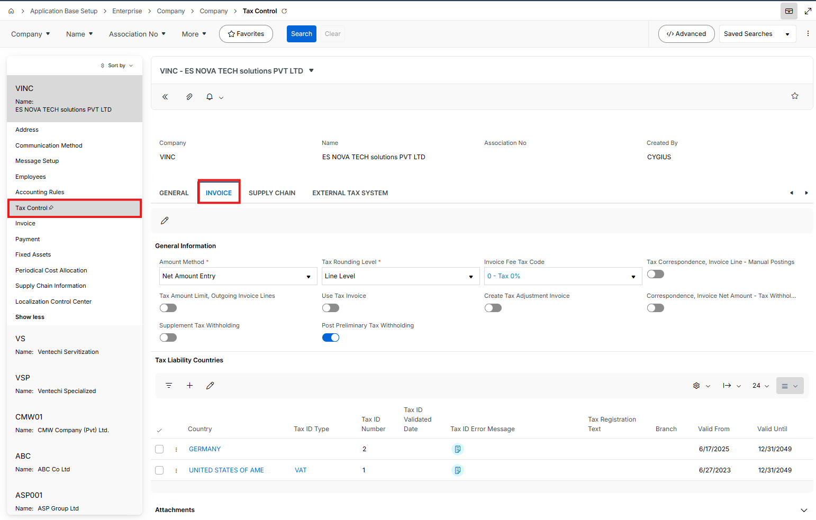

  - Supply Chain sub-tab

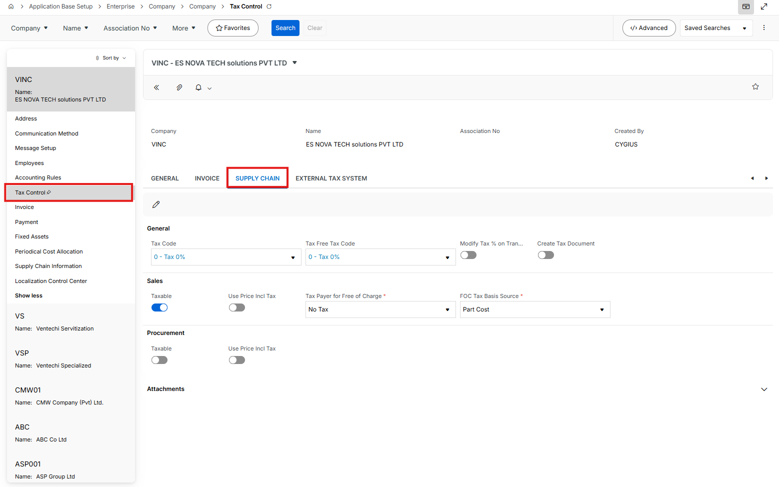

  - External Tax System sub-tab

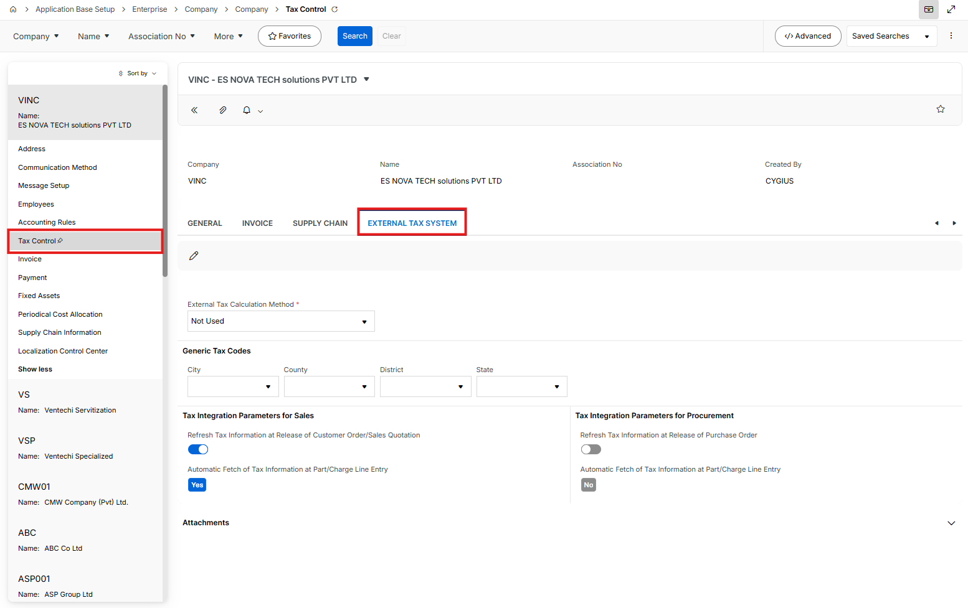

- Copy all Invoice data
  - General sub-tab

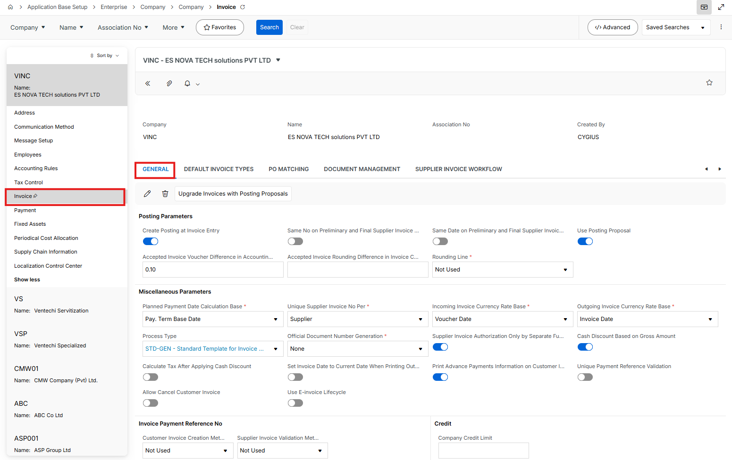

  - Default Invoice Types sub-tab

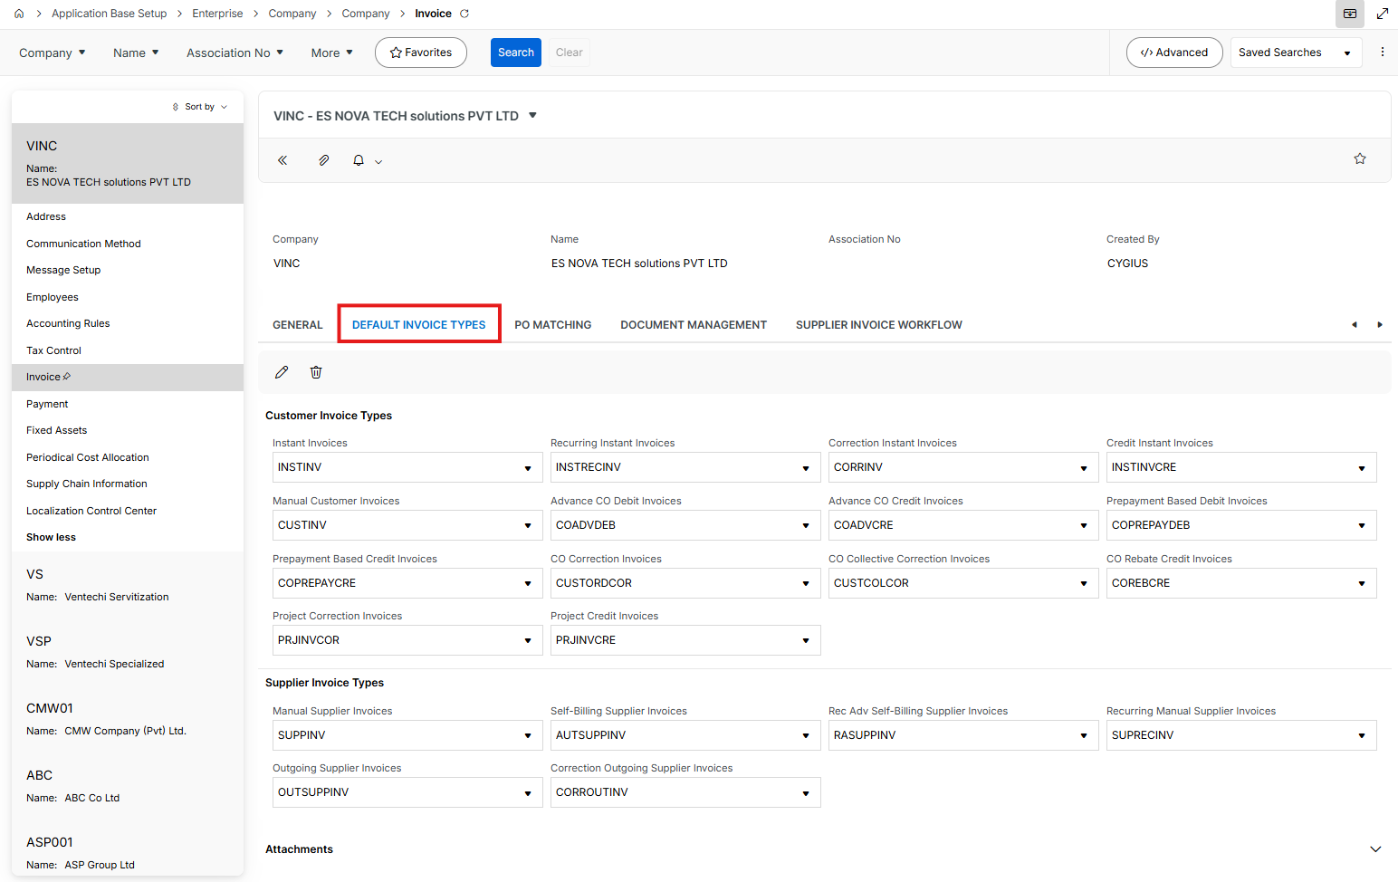

  - PO Matching sub-tab

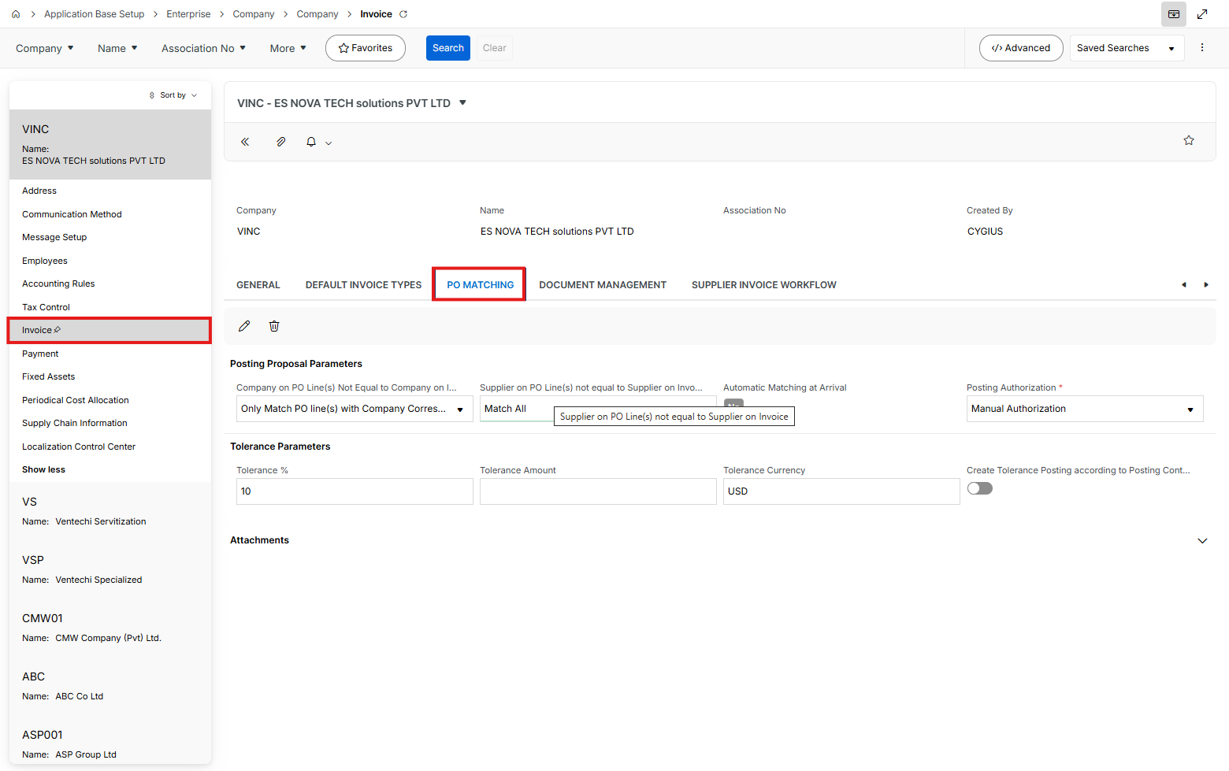

  - Document Management sub-tab

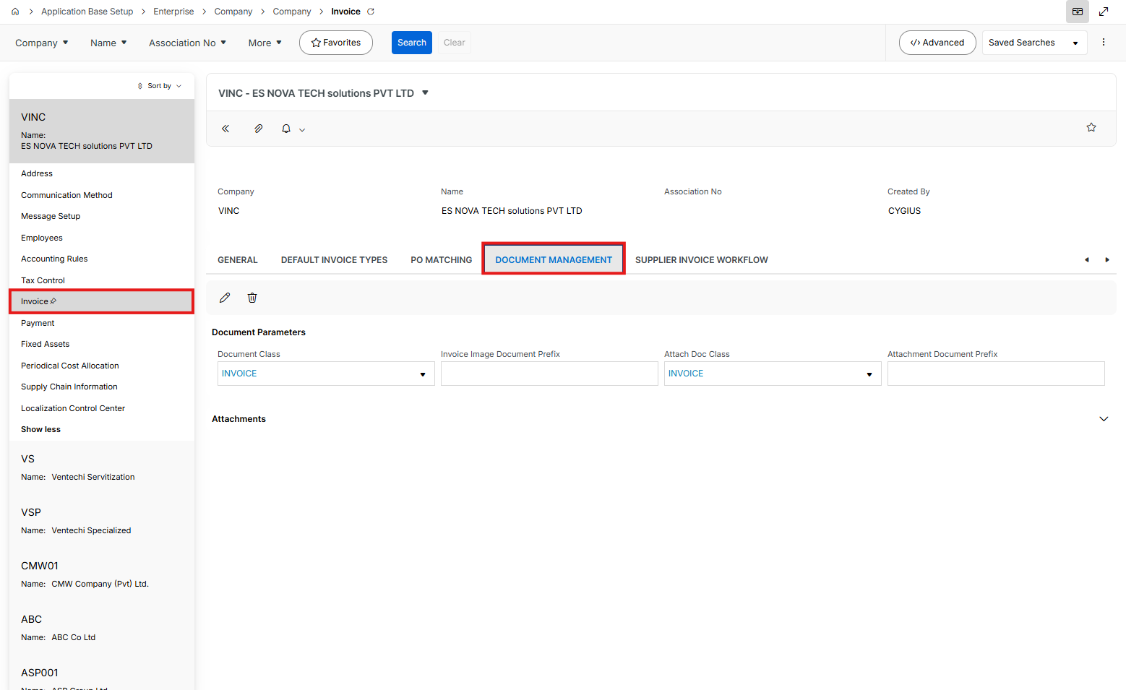

Supplier Invoice Workflow sub-tab

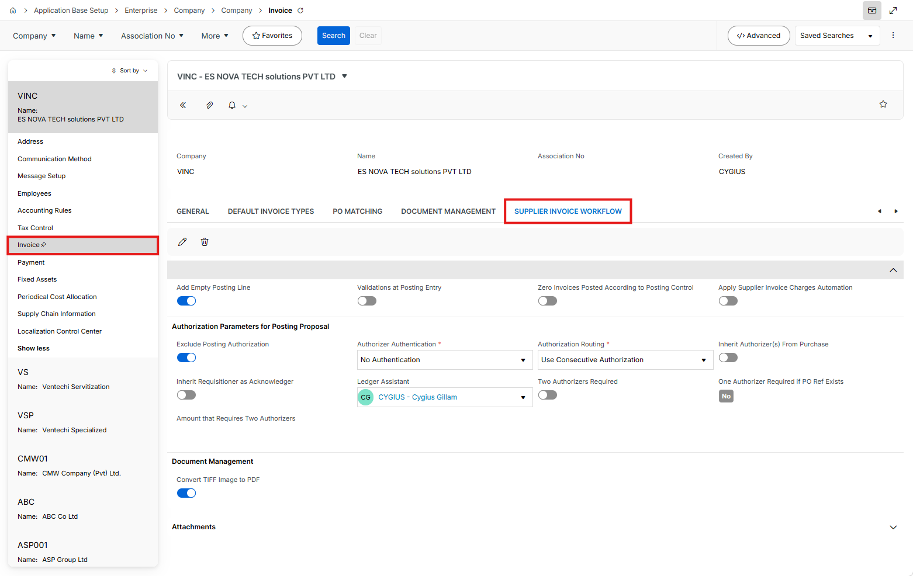

Copy all Payment data

General sub-tab

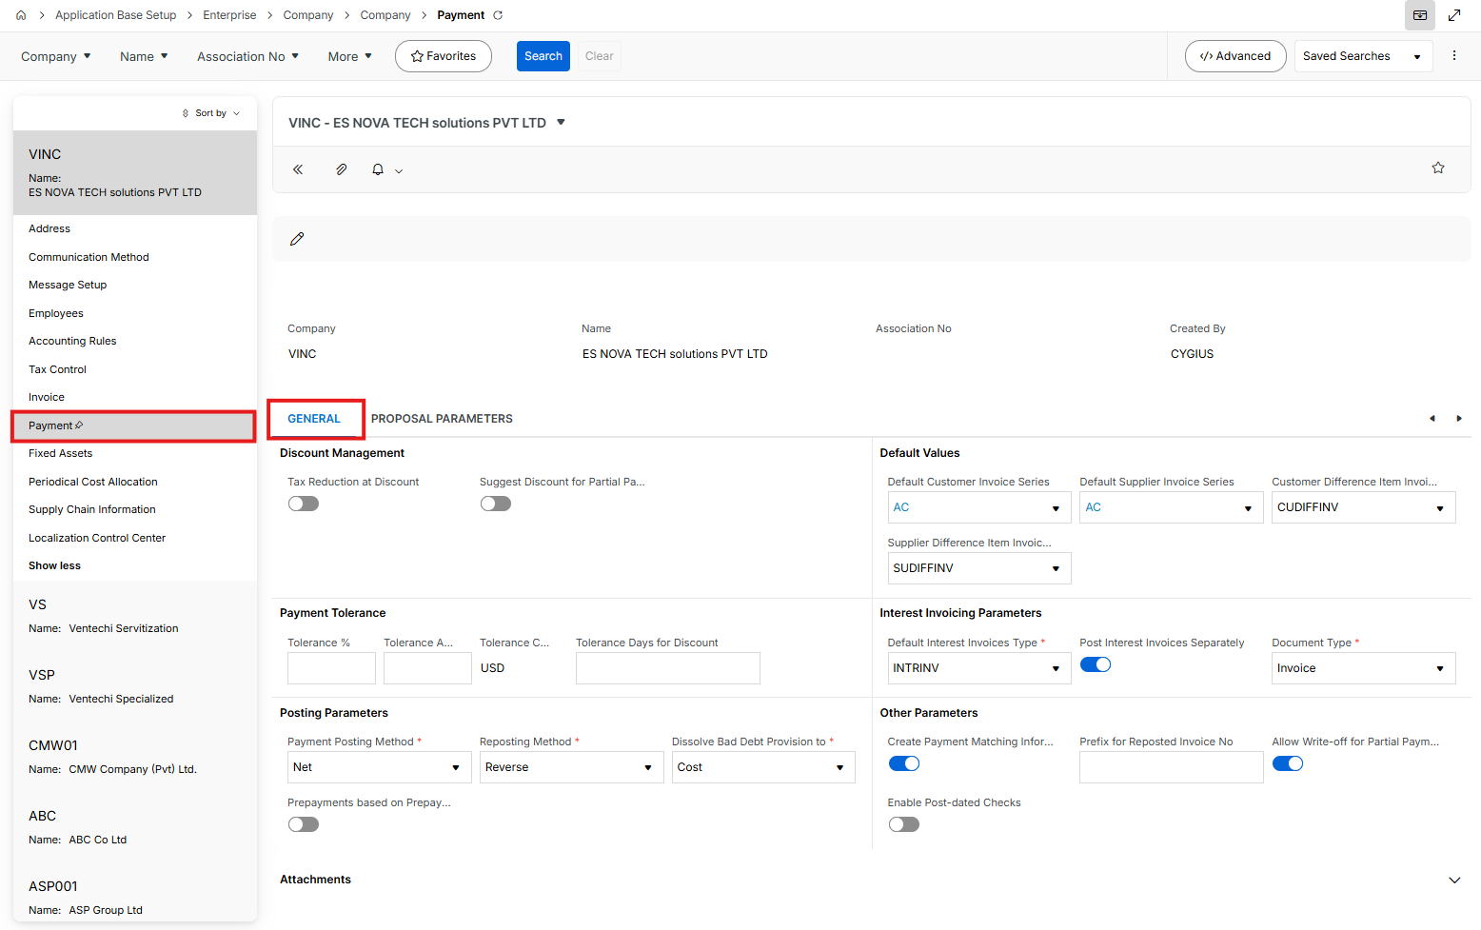

Proposal Parameters sub-tab

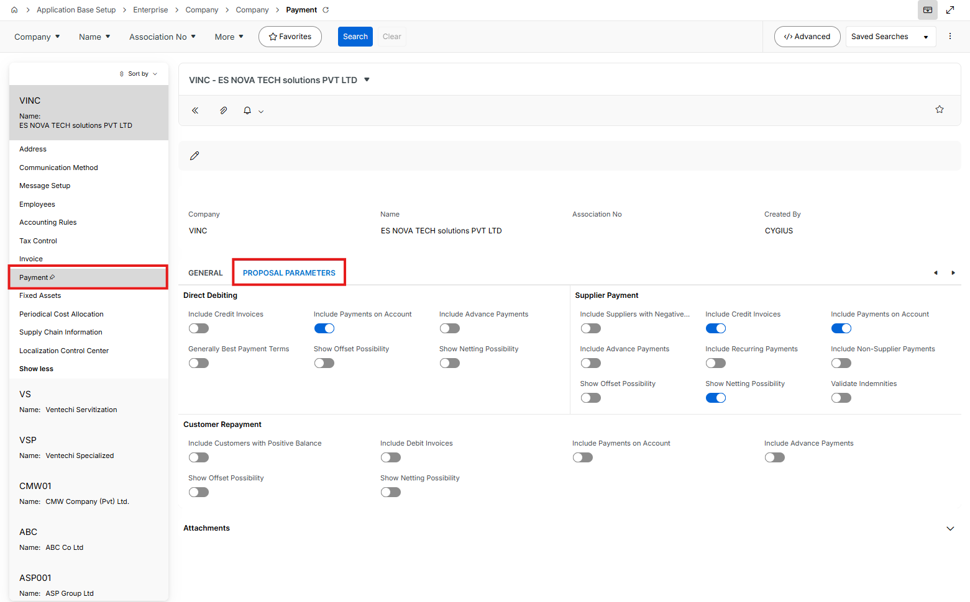

Copy all Fixed Assets data

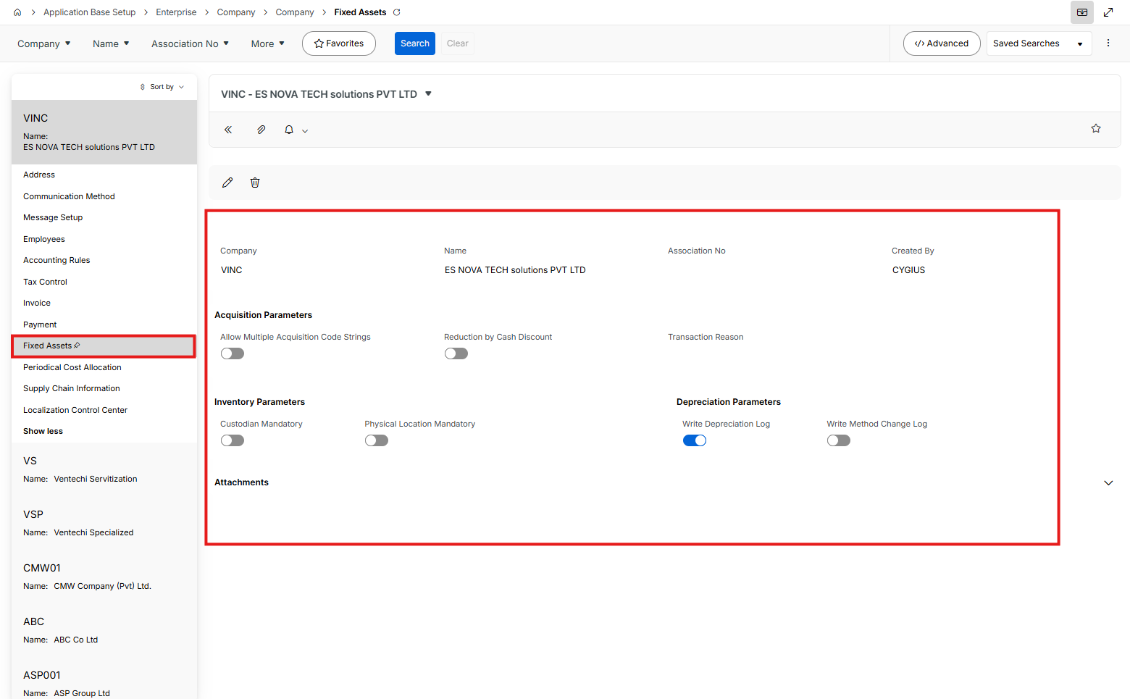

Copy all Periodical Cost Allocation data

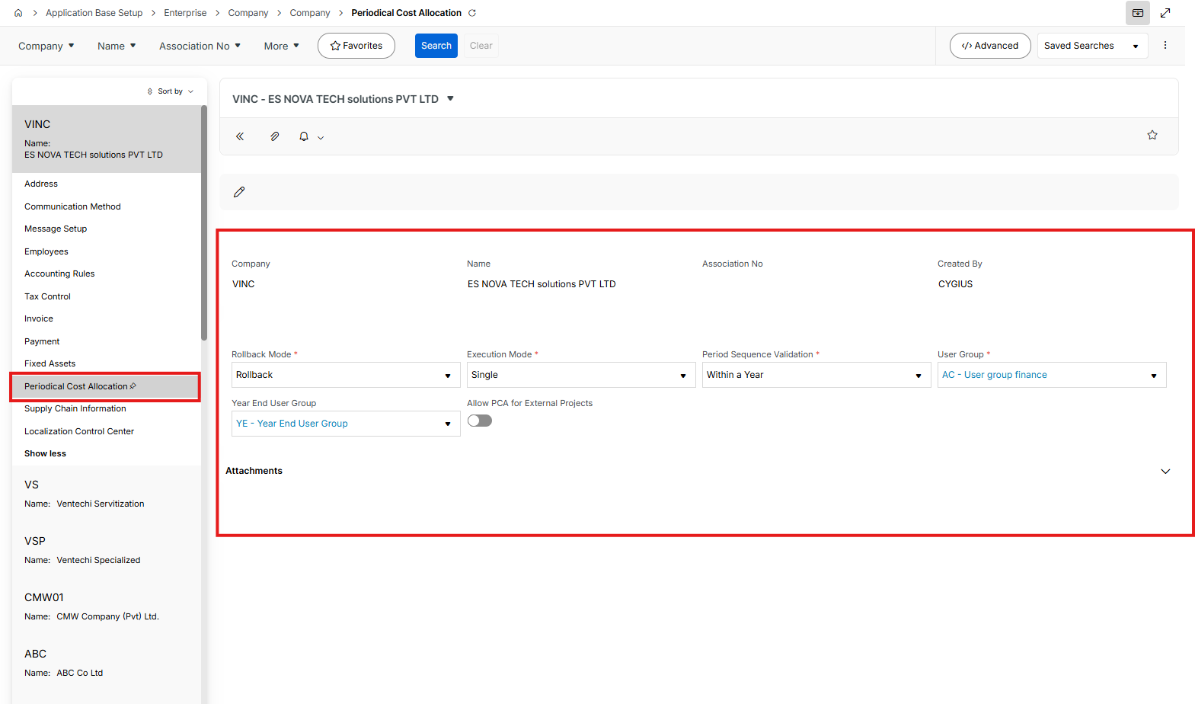

Copy all Supply Chain Information data in 4 tabs

General sub-tab

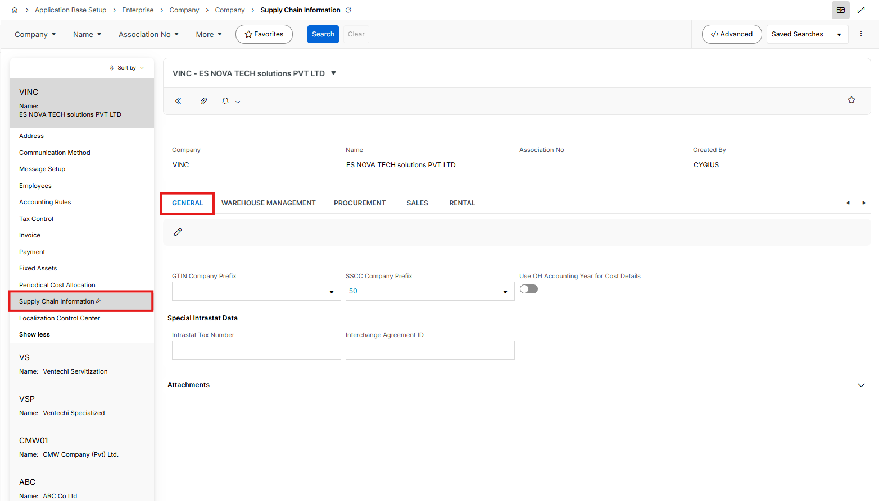

Warehouse Management sub-tab

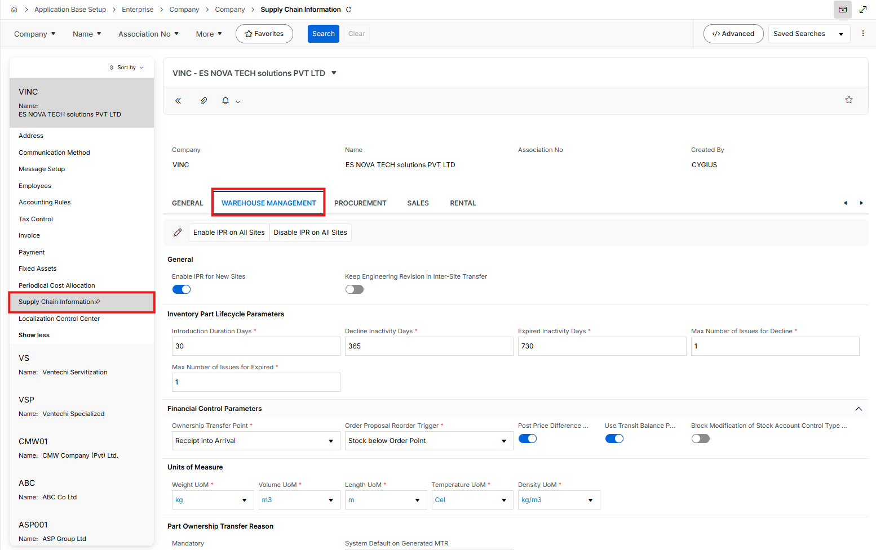

Procurement sub-tab

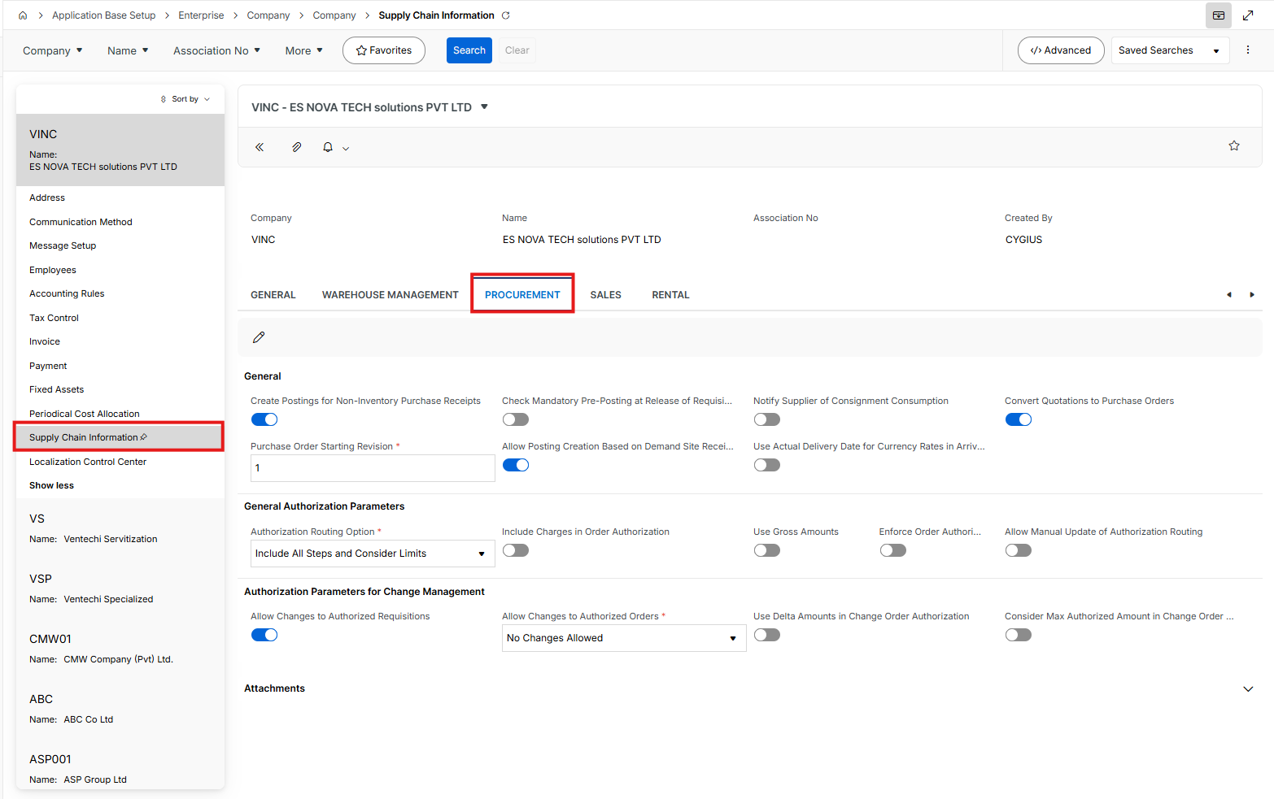

Sales sub-tab

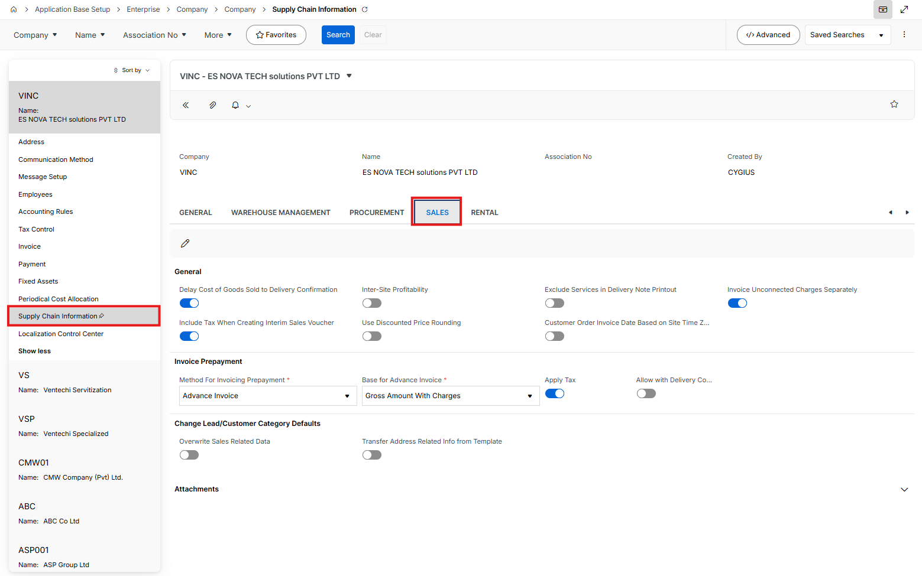

Rental sub-tab

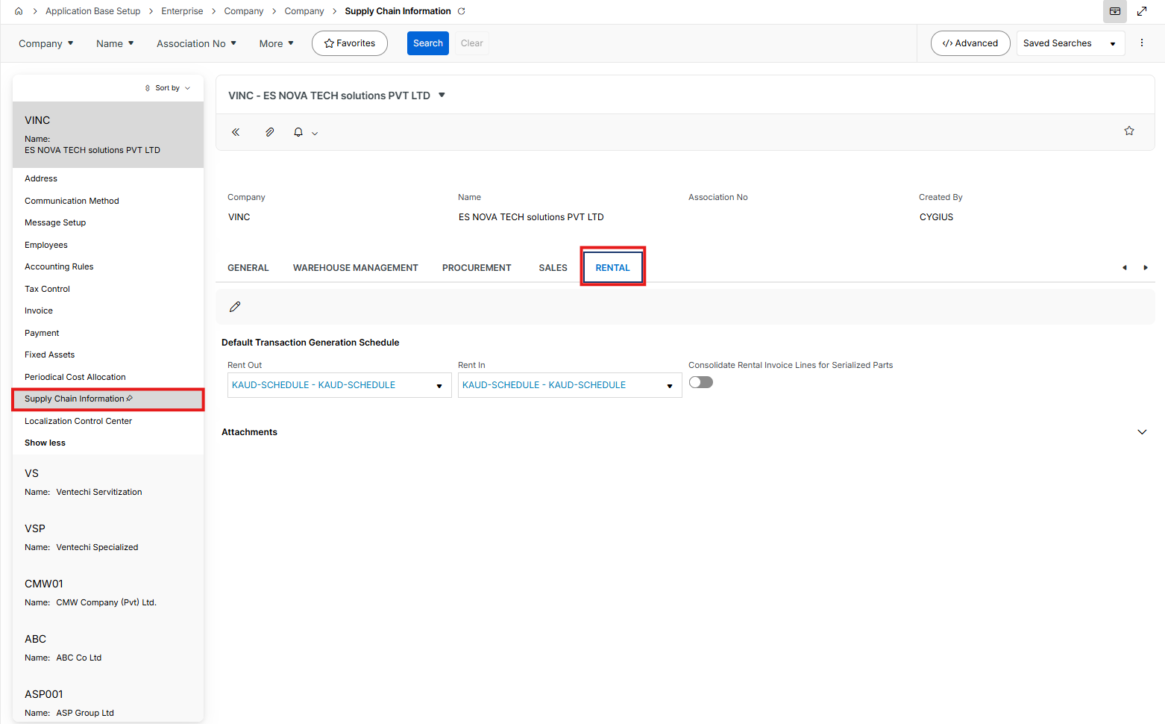

Copy all Localization tab data

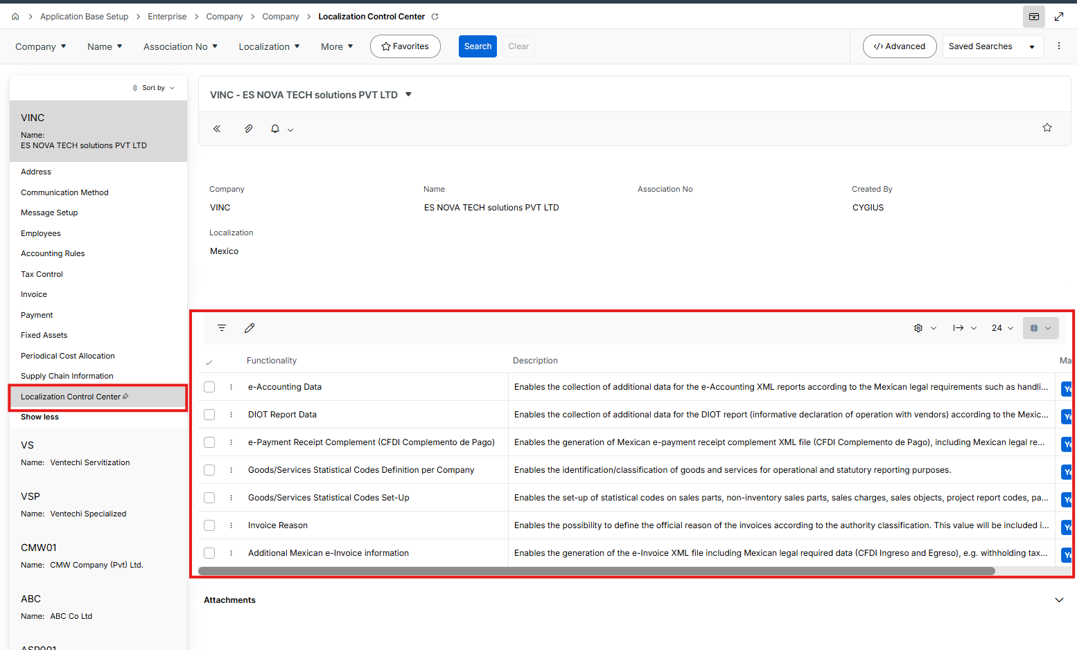

Once the companies are created find all LUs in below view and copy all LU fields

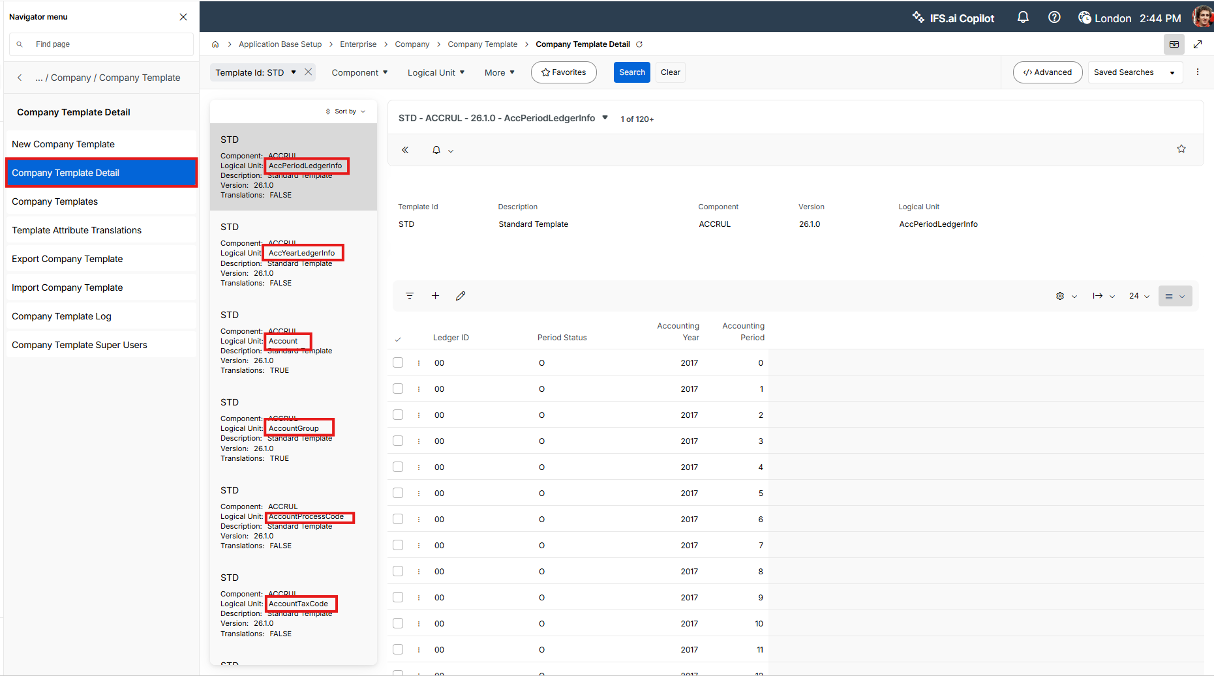

Site

- Copy all Site level data including data in Extended Site Info tab

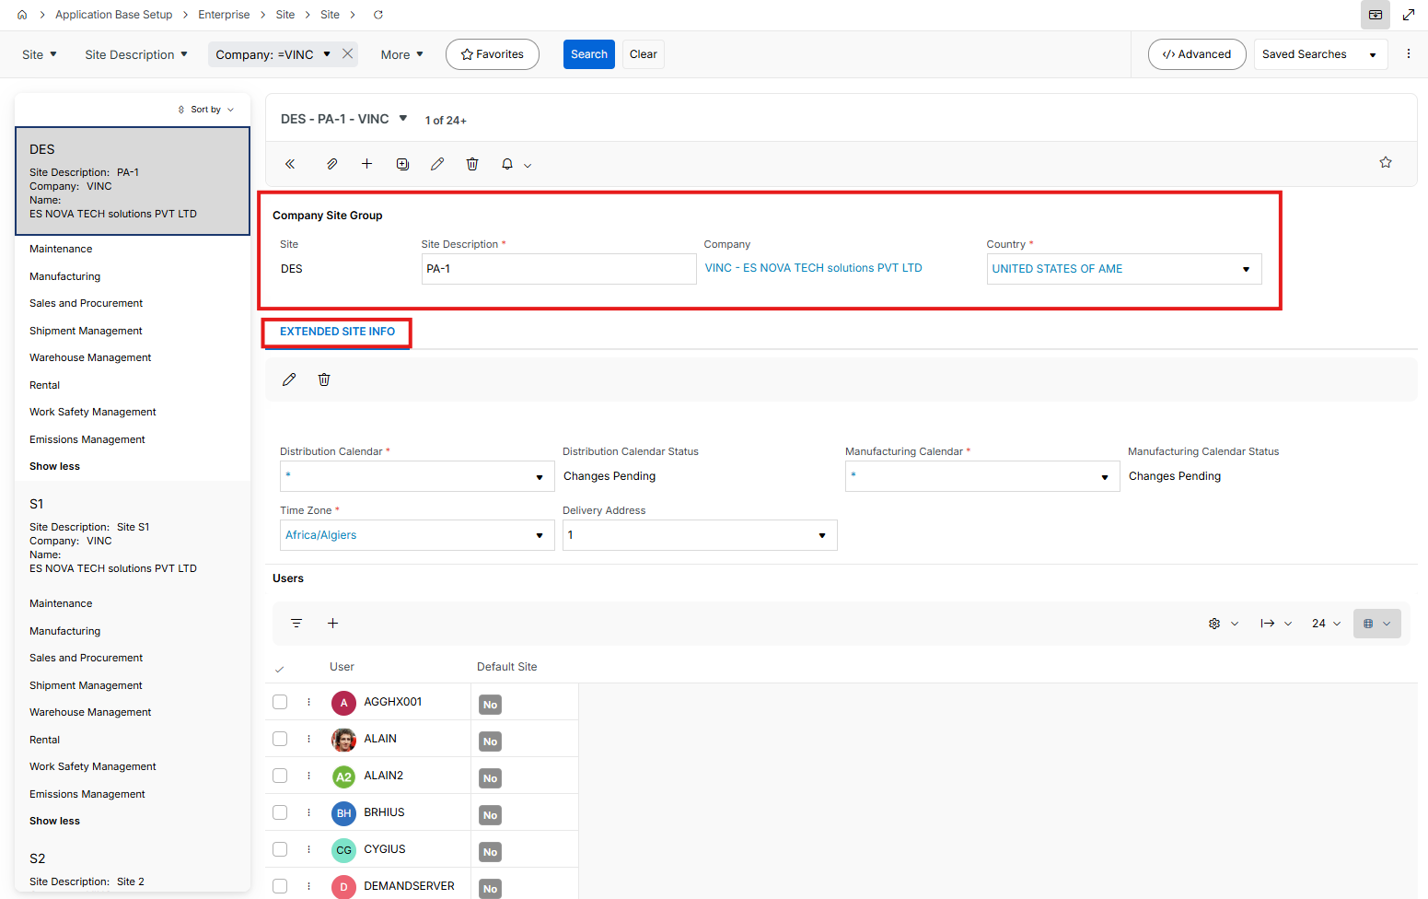
- Copy all data in Maintenance tab

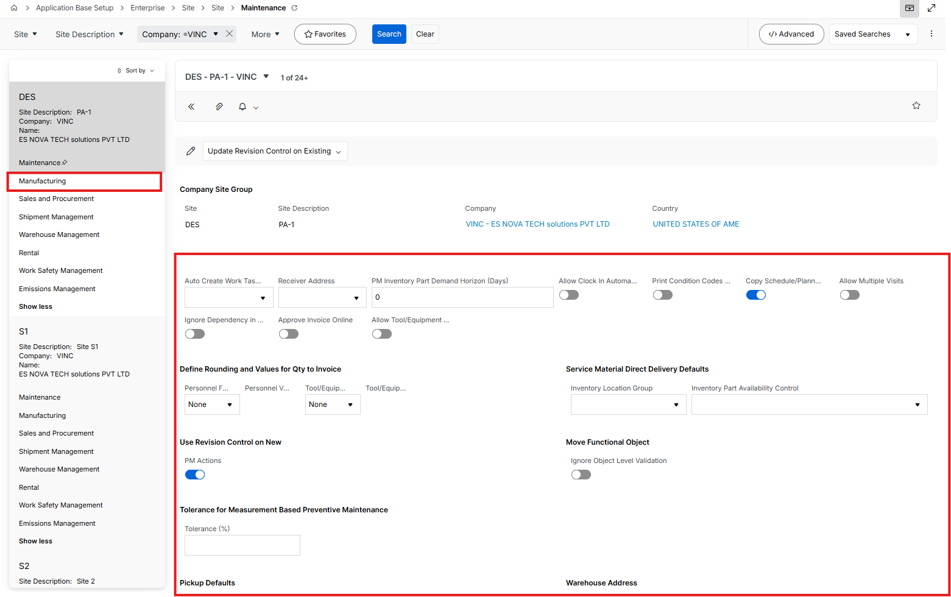

- Copy all data in Manufacturing sub tabs below
  - General

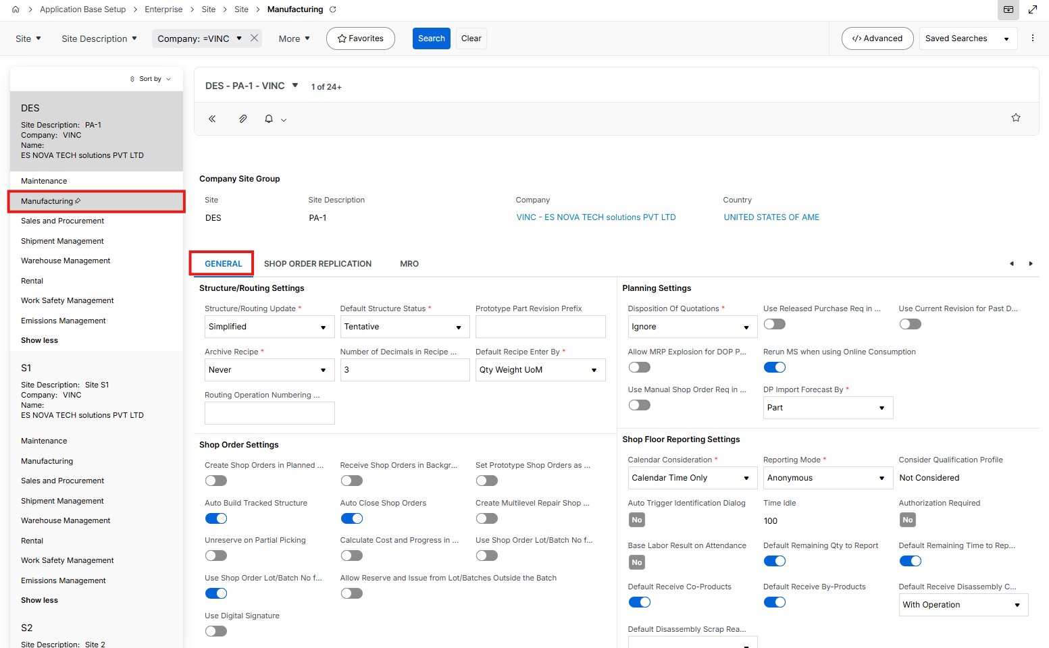

  - Shop Order Replication

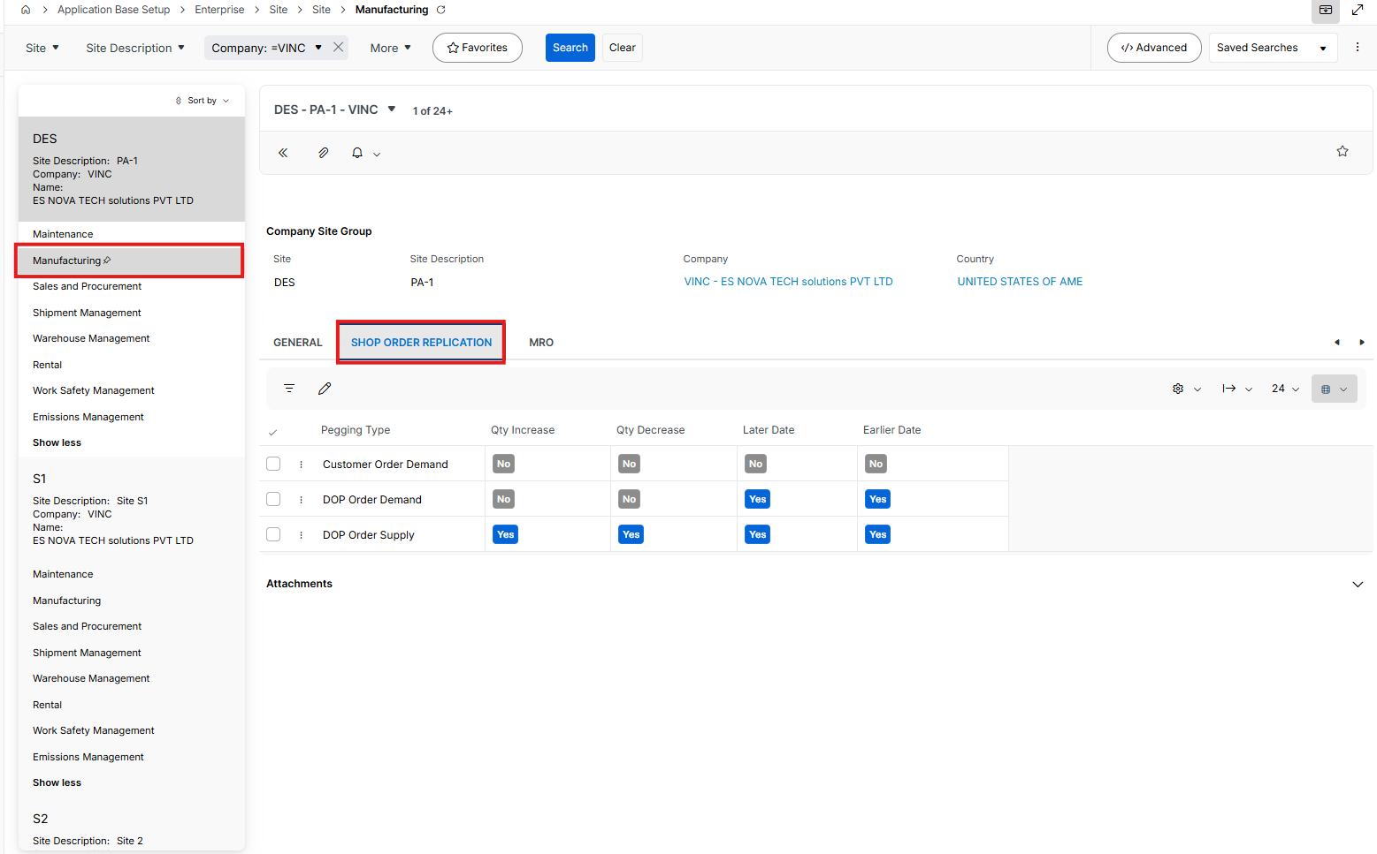

- Copy all data in Supply Chain tab

Only Document Address should be fetched

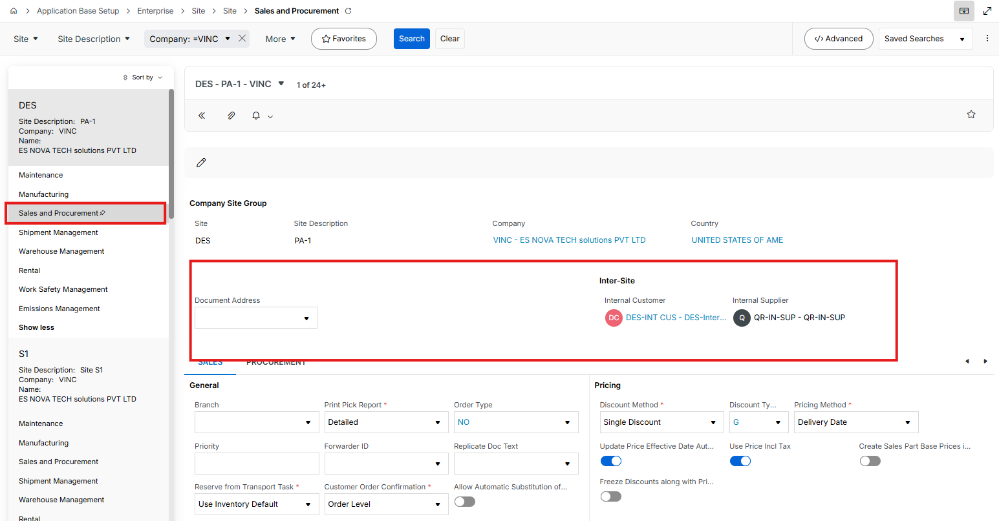

  - Copy Sales sub tab data

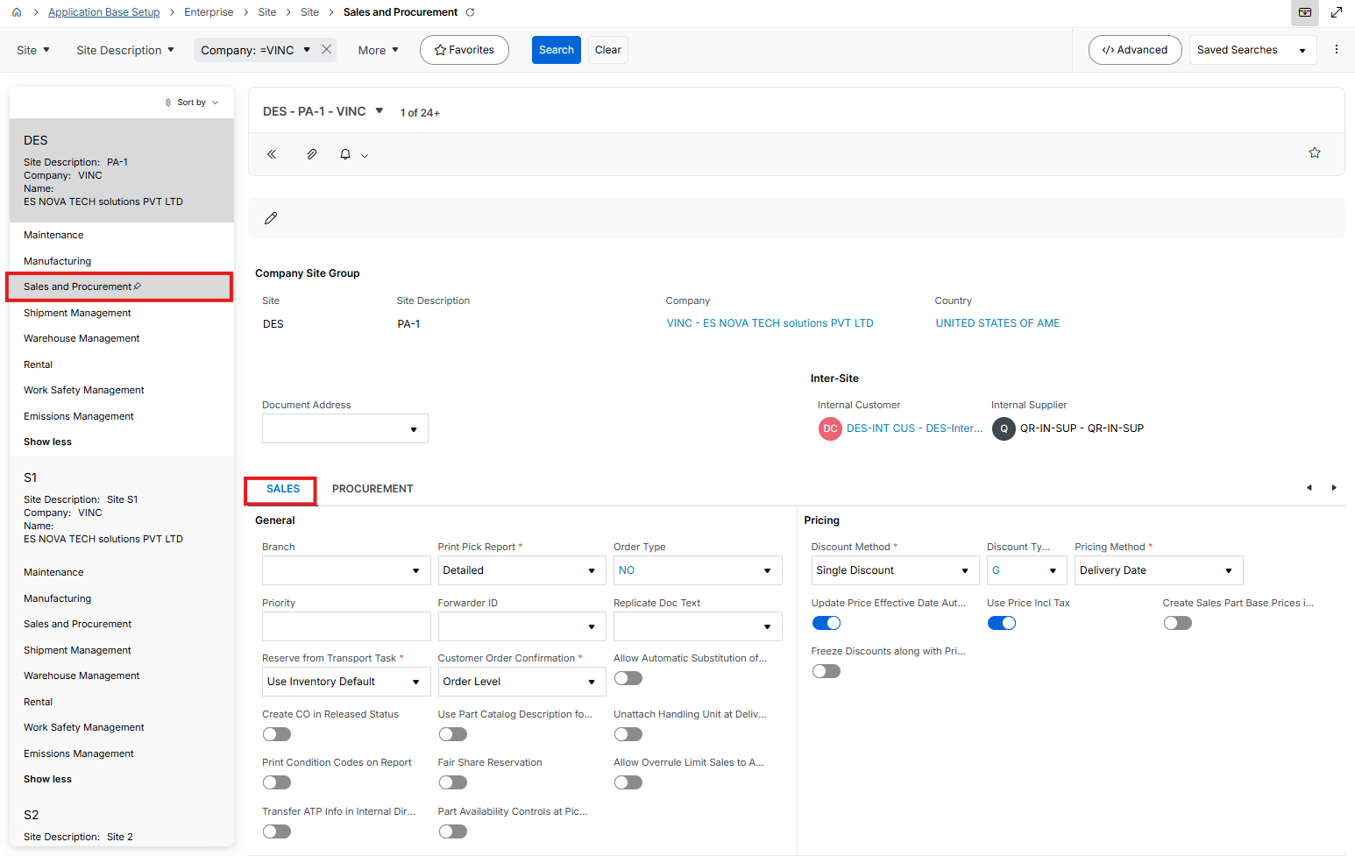

  - Copy Procurement sub tab data

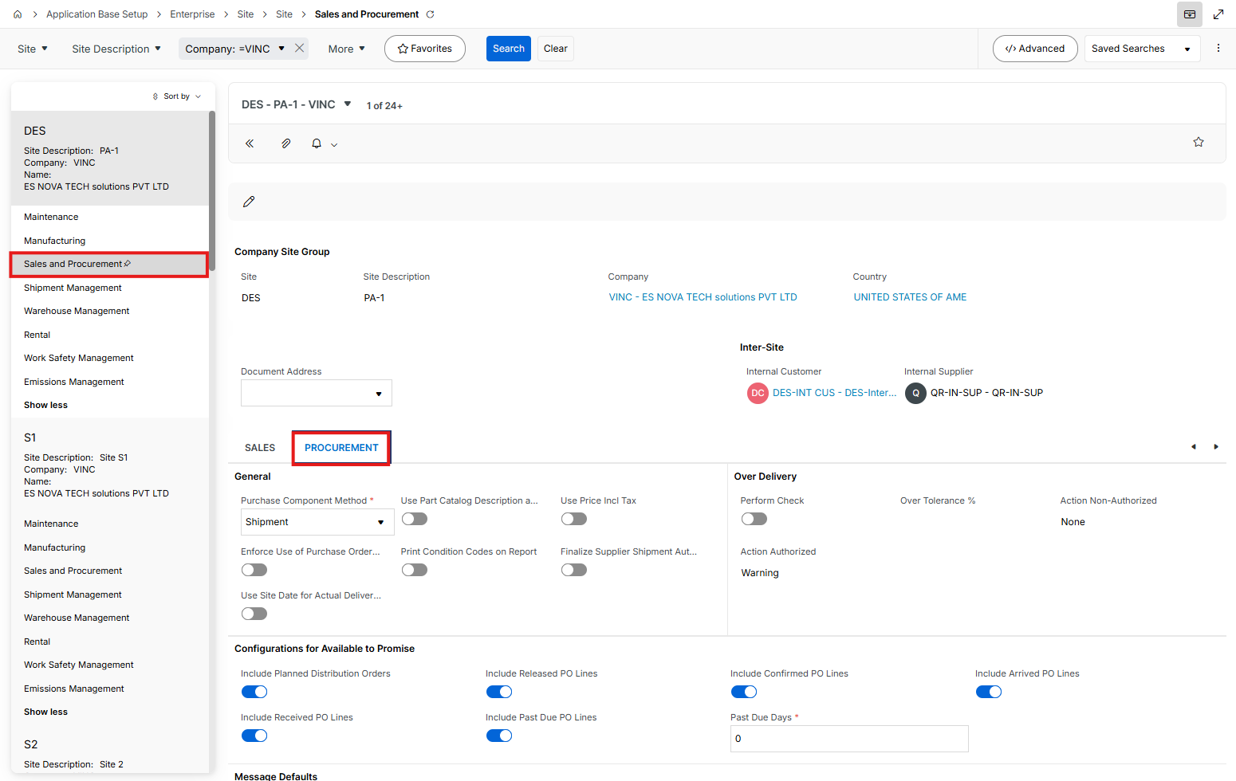

- Copy all data in Shipment Management tab

(While fetching data, Locations are not created yet. Therefore if you get any error due to fetching data on “Default Shipment Location”, please leave it blank)

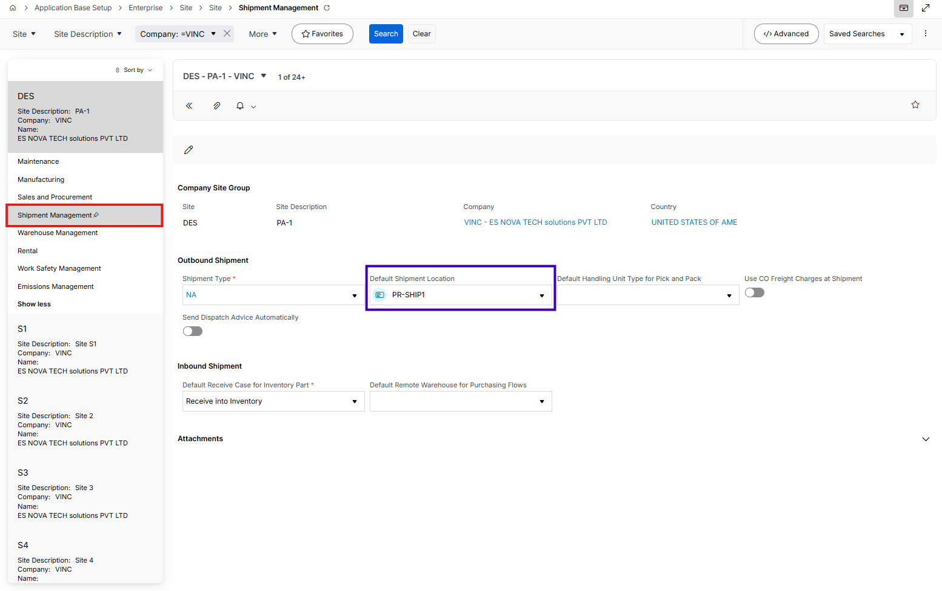
- Copy all data in Warehouse Management sub tabs below
  - General

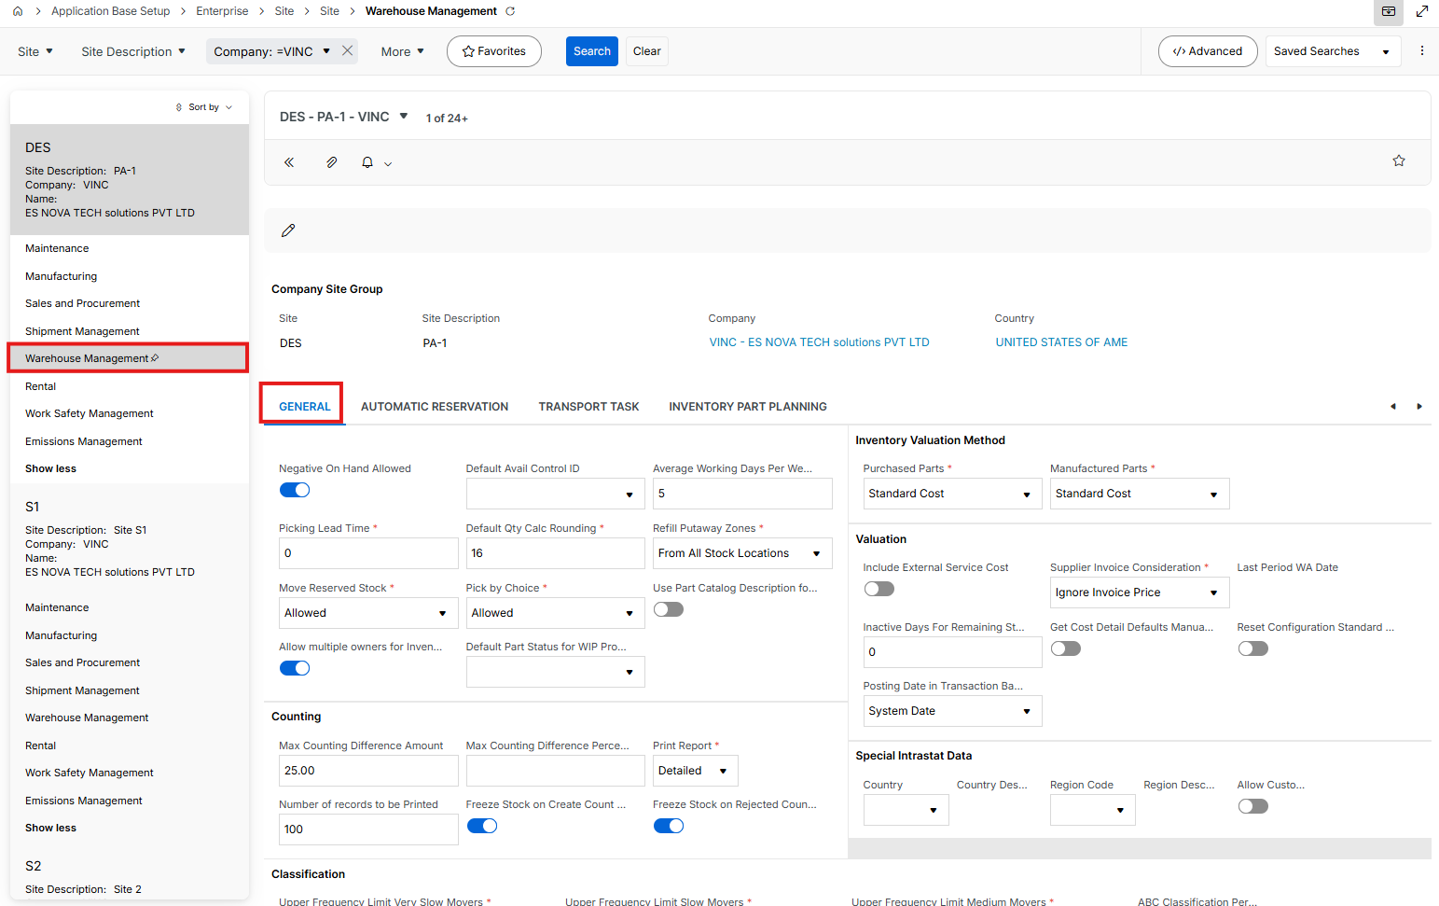

  - Automatic Reservation

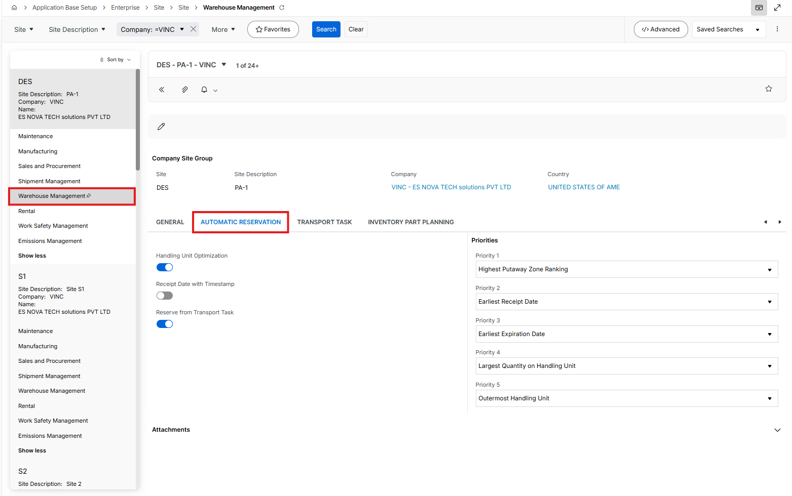

  - Transport Task

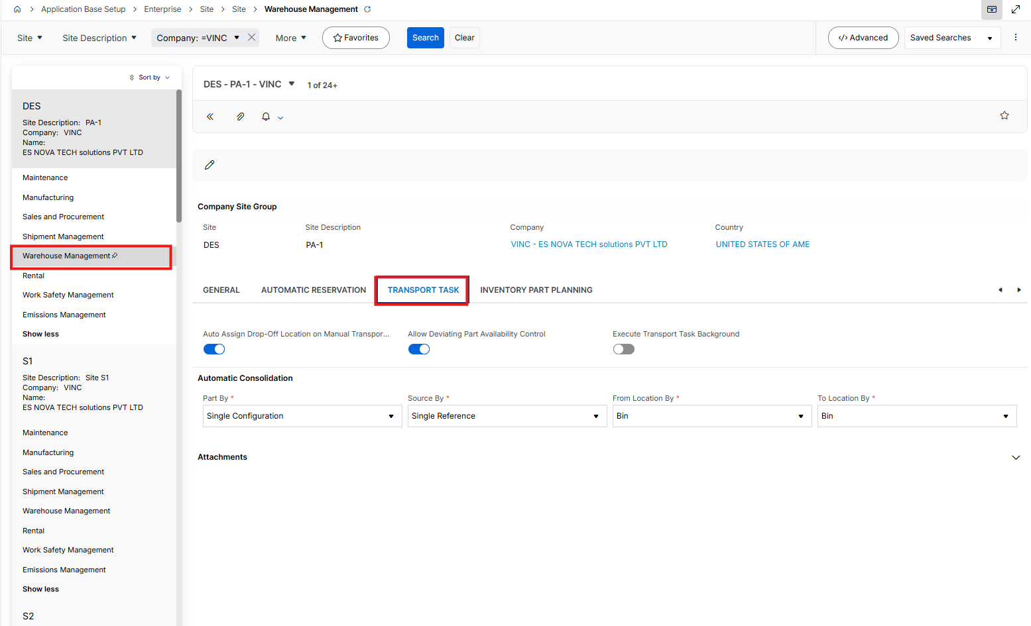

  - Inventory Part Planning

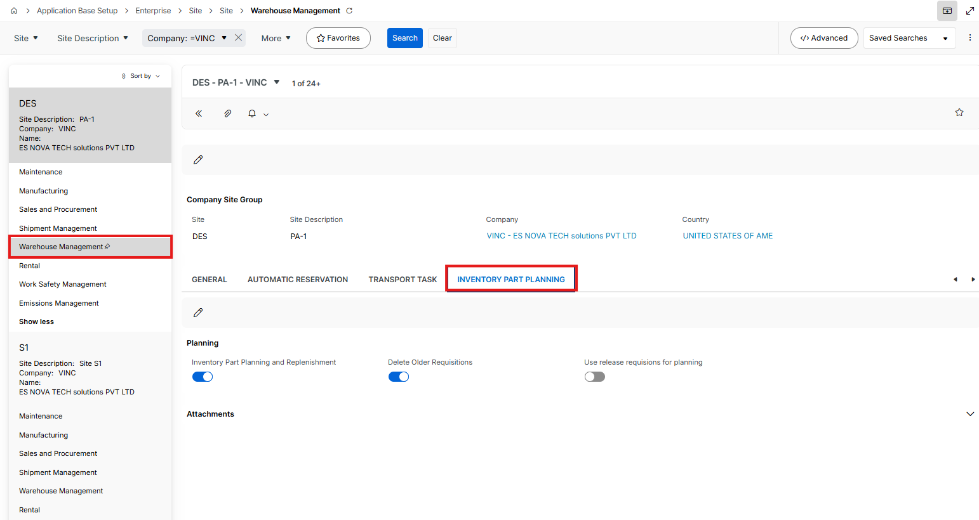

- Copy all data in Rental tab

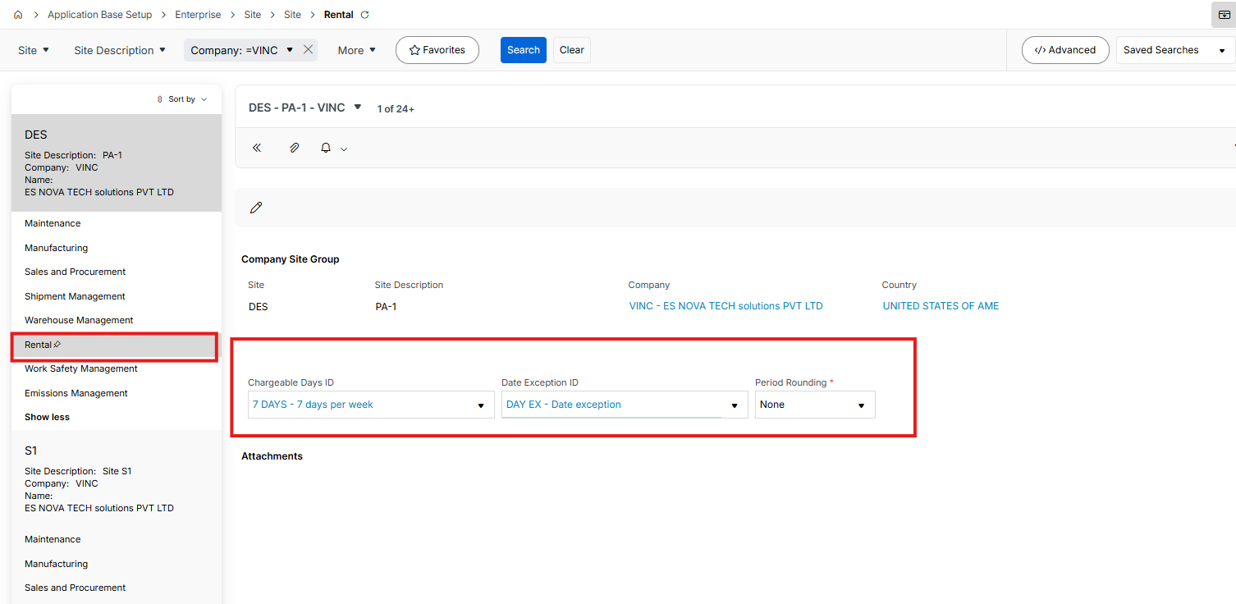

Customer

- Customer – General Data
Go to Sales Part page and create a new
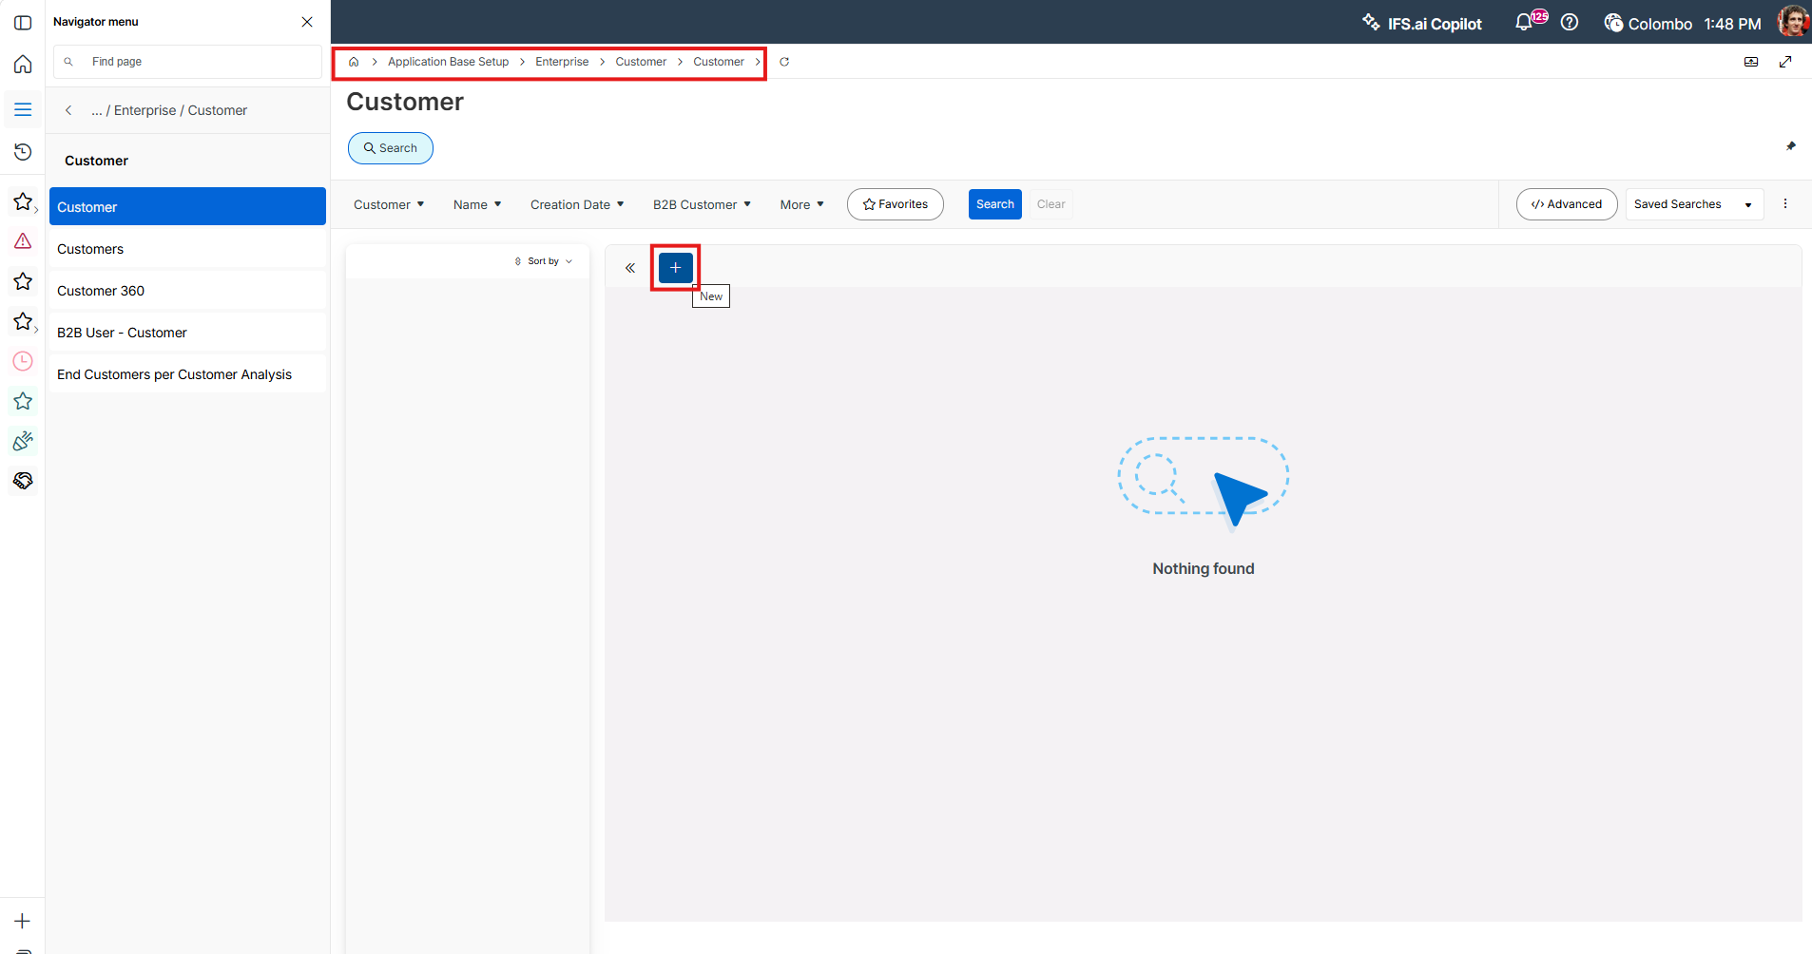

- Fill fields below and save
Add a customer and a name,
Set a default language and country
Set Category as Customer
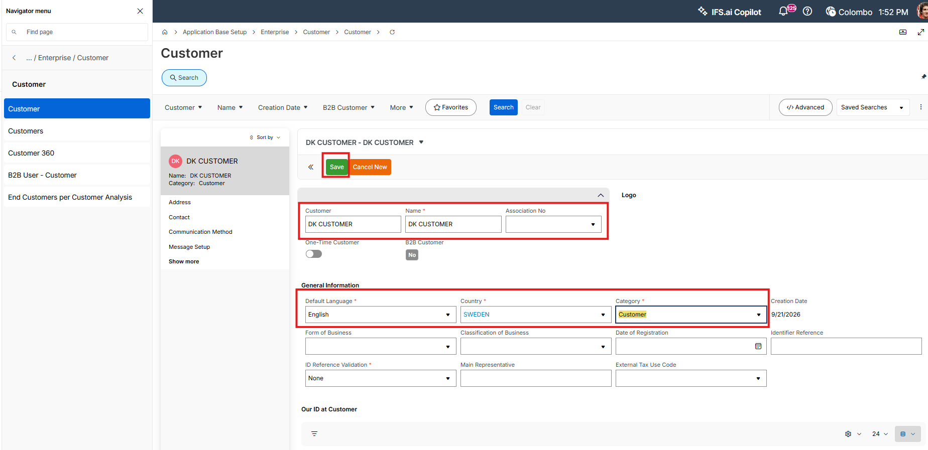

- Go to Address tab and click new

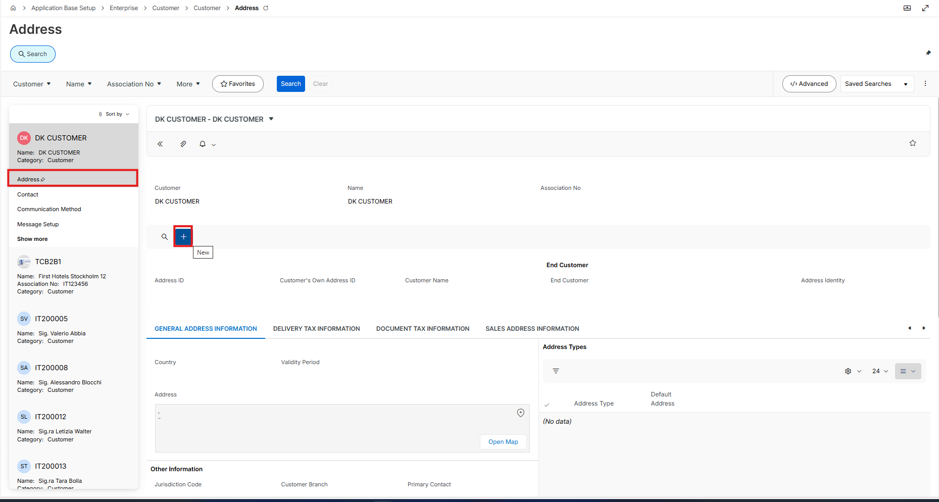

- Add a Addres ID and click on edit button on address area

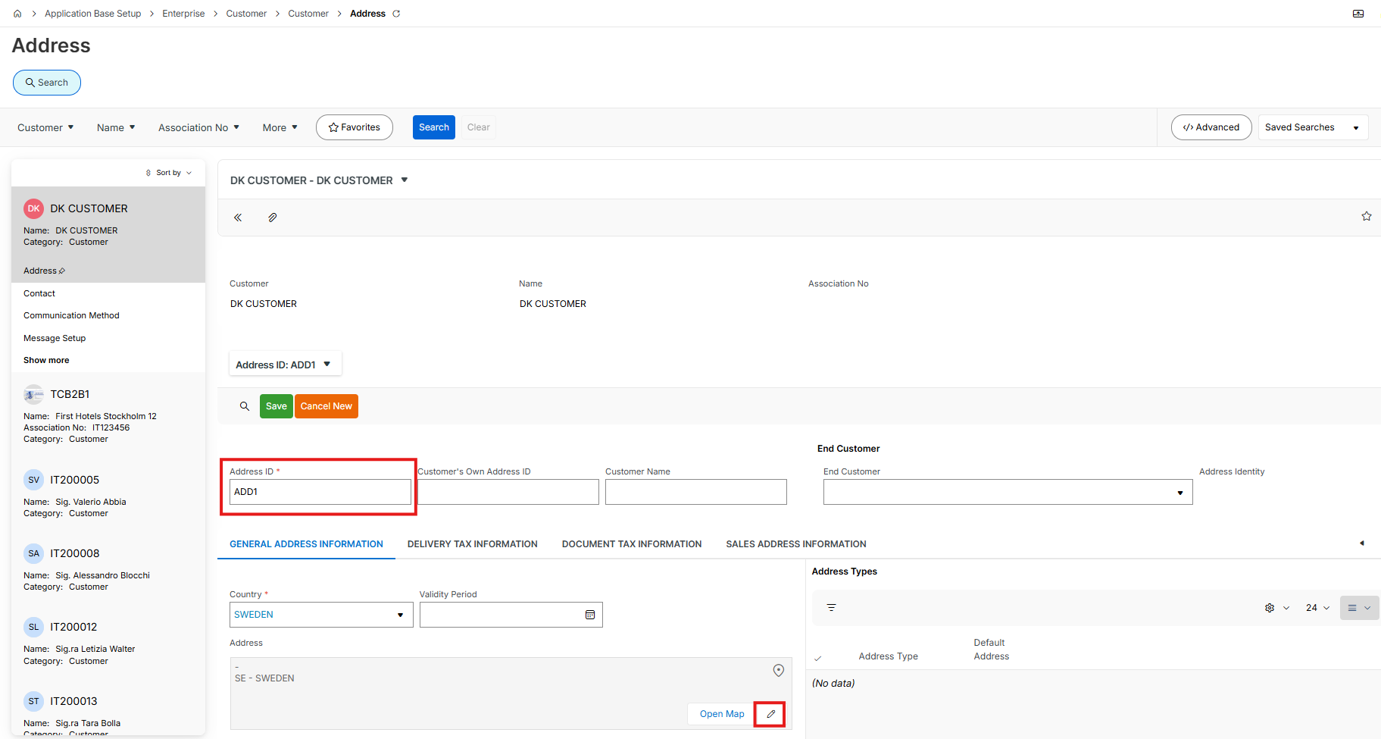

- e. Add address details to the assisst window and click OK

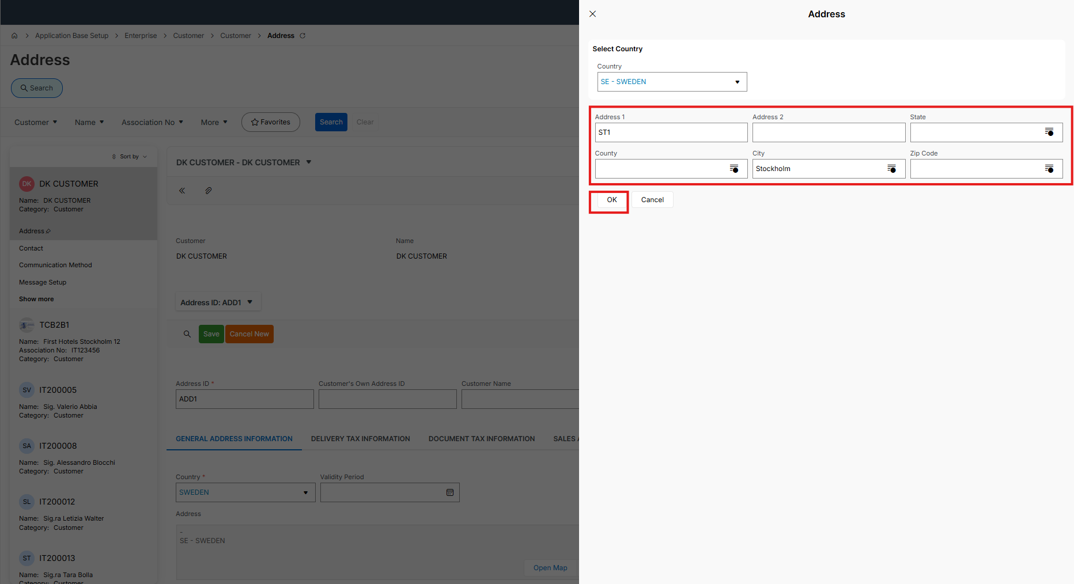

- Save address details

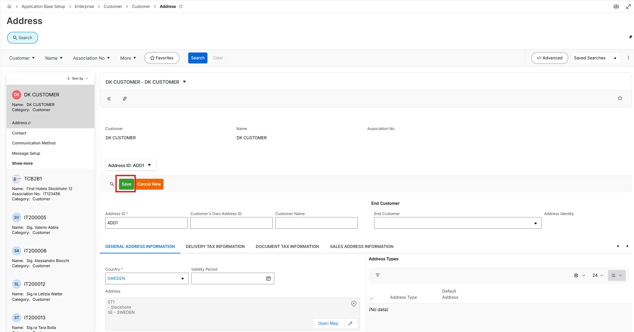

- Go to Delivery Tax Information sub tab and click on new

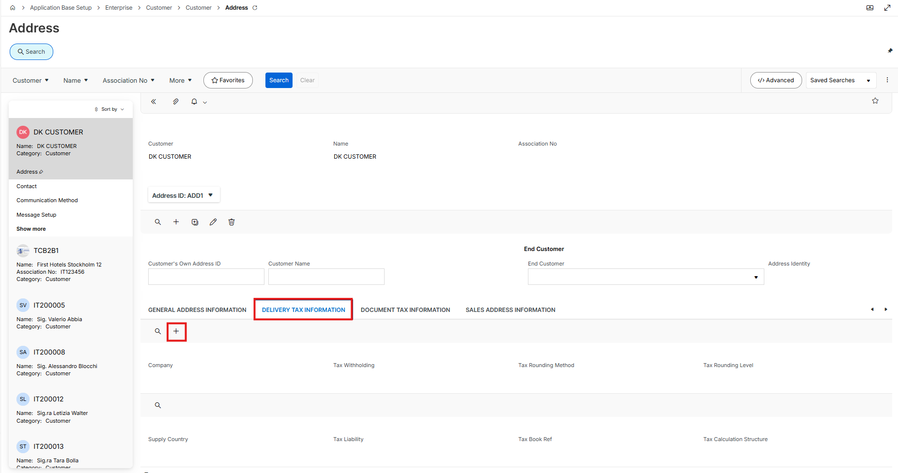

- Add a company and fill rest of the data

Save data

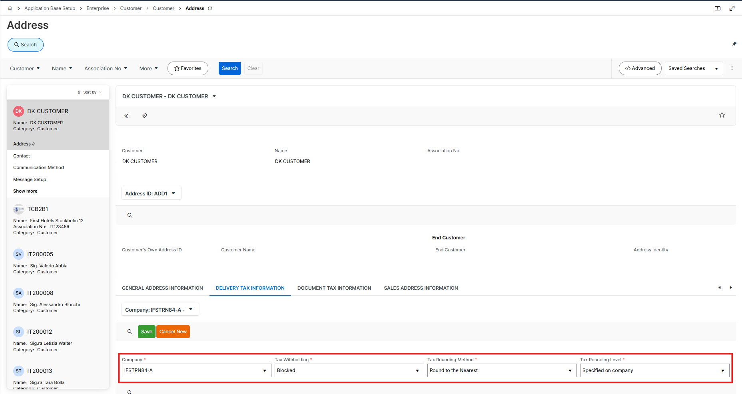

- Click new button on tax area and add a tax code

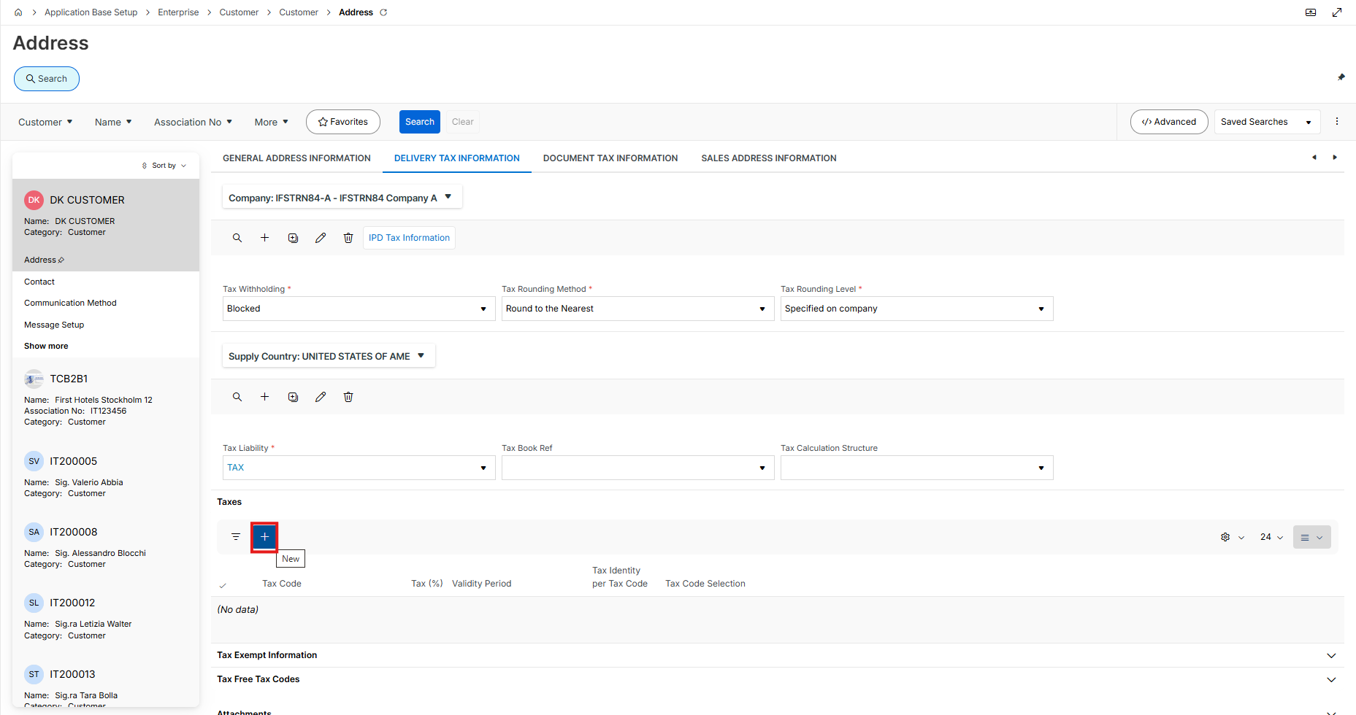

- Add a tax code and save

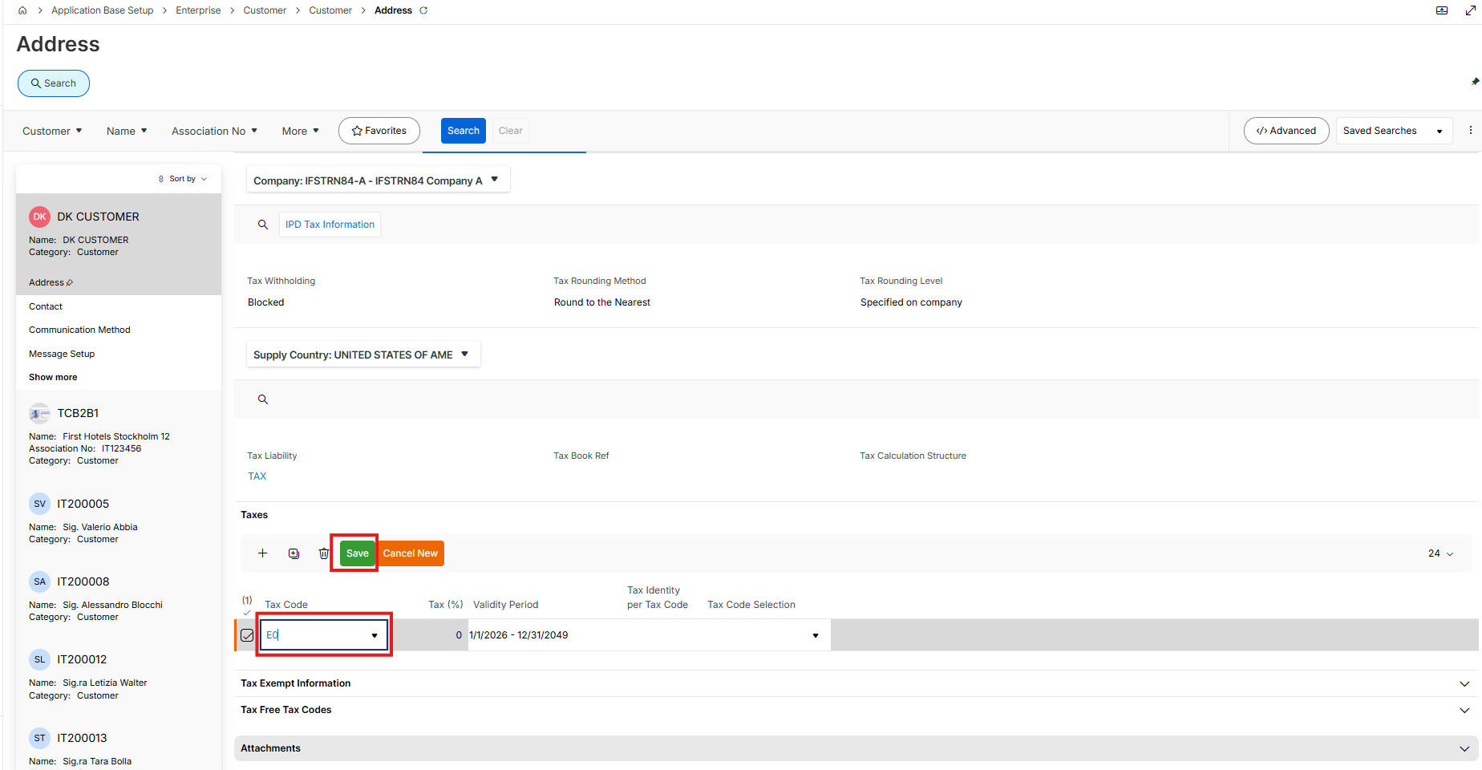

- Go to Sales Address Information subtab and click new

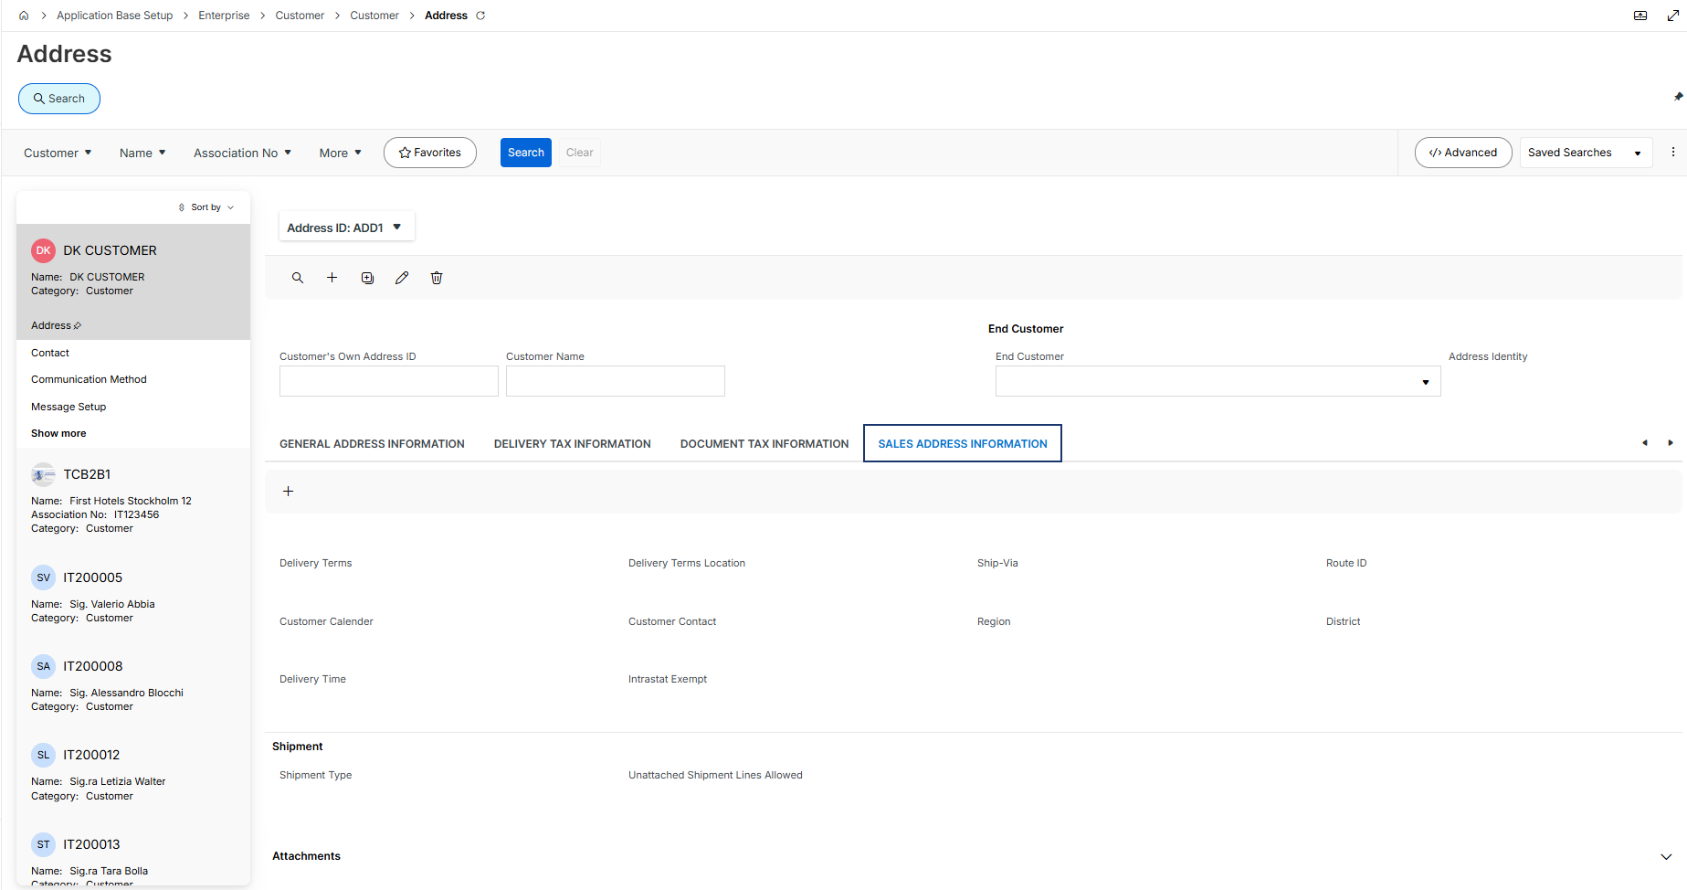

- Fill below fields and save

Delivery Terms

Ship Via

Shipment Type

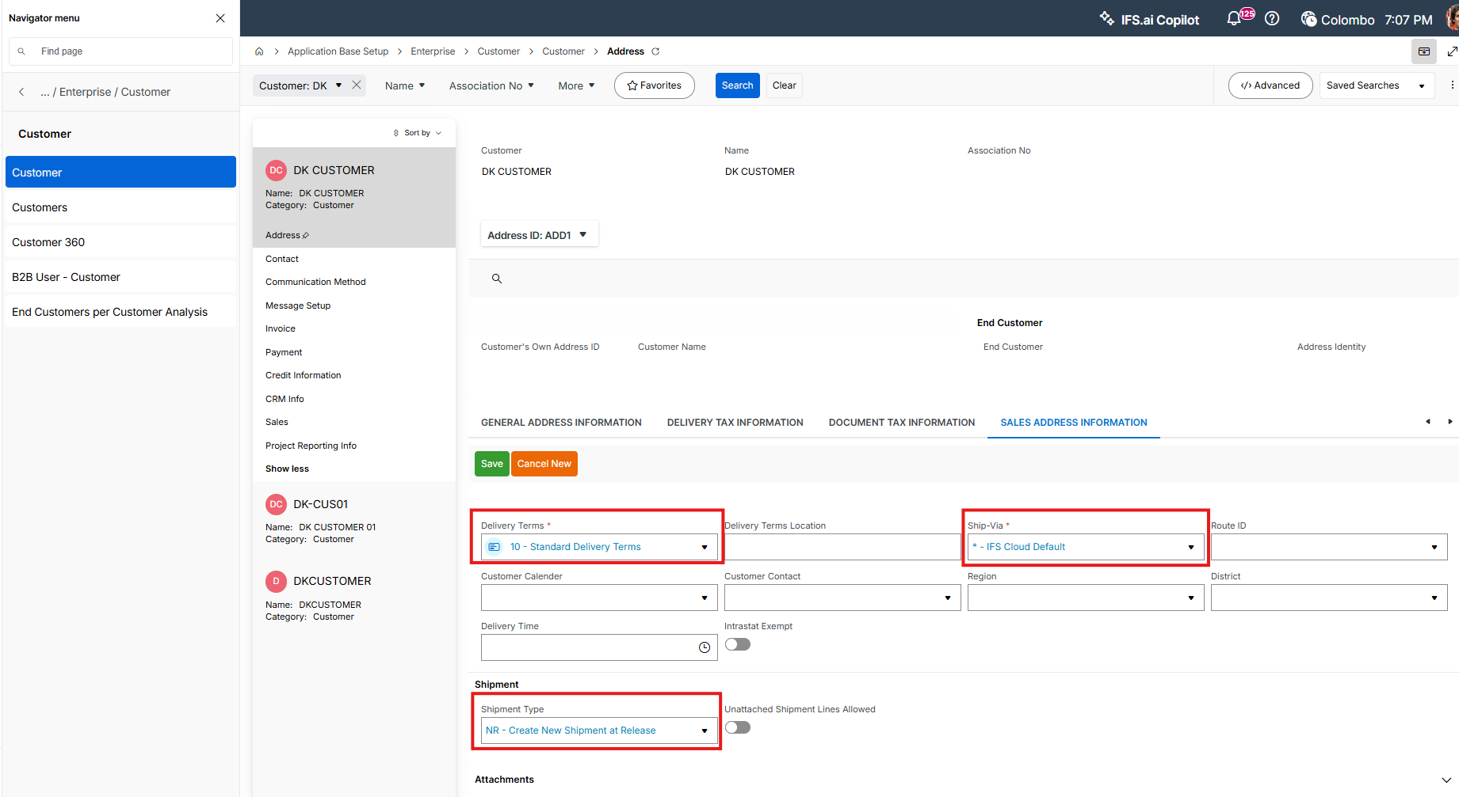

- Go to Invoice tab and click new

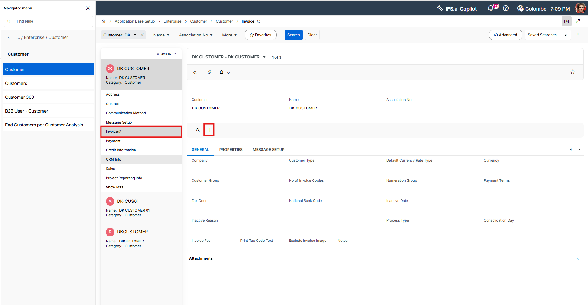

- Add a Company and a Payment Type and set Customer Type as External and Customer Group as External

Save the record

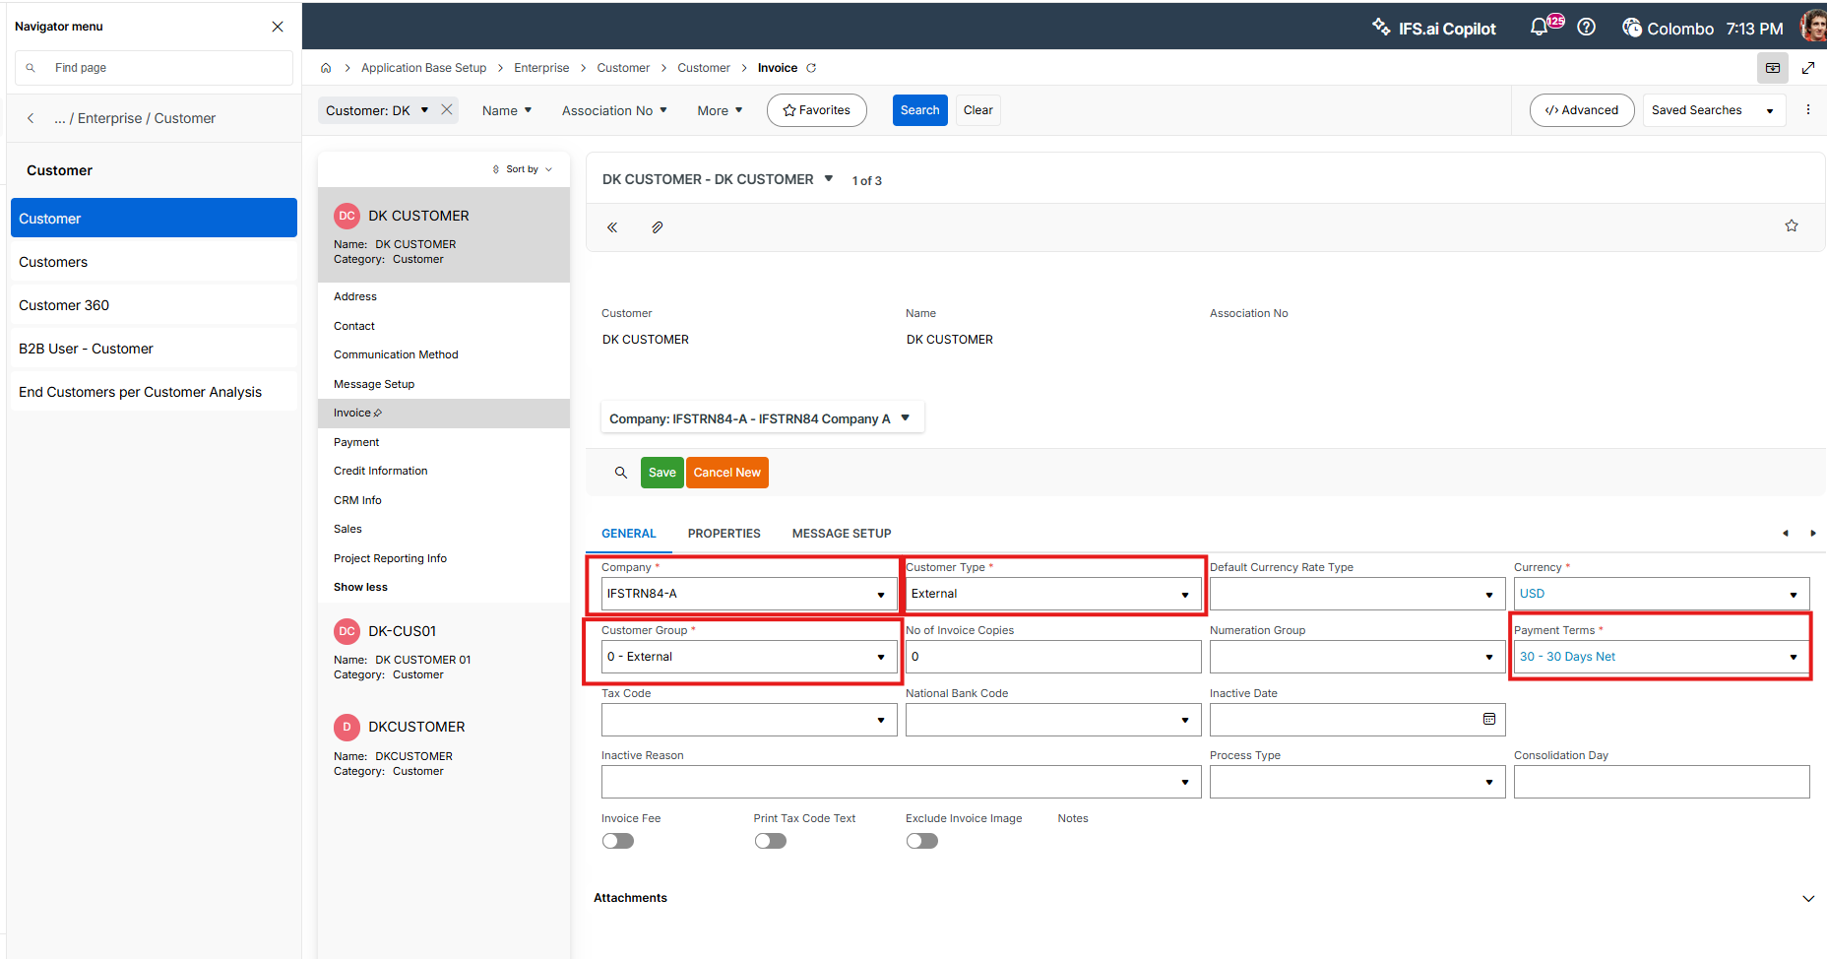

- Go to Payment tab and click new

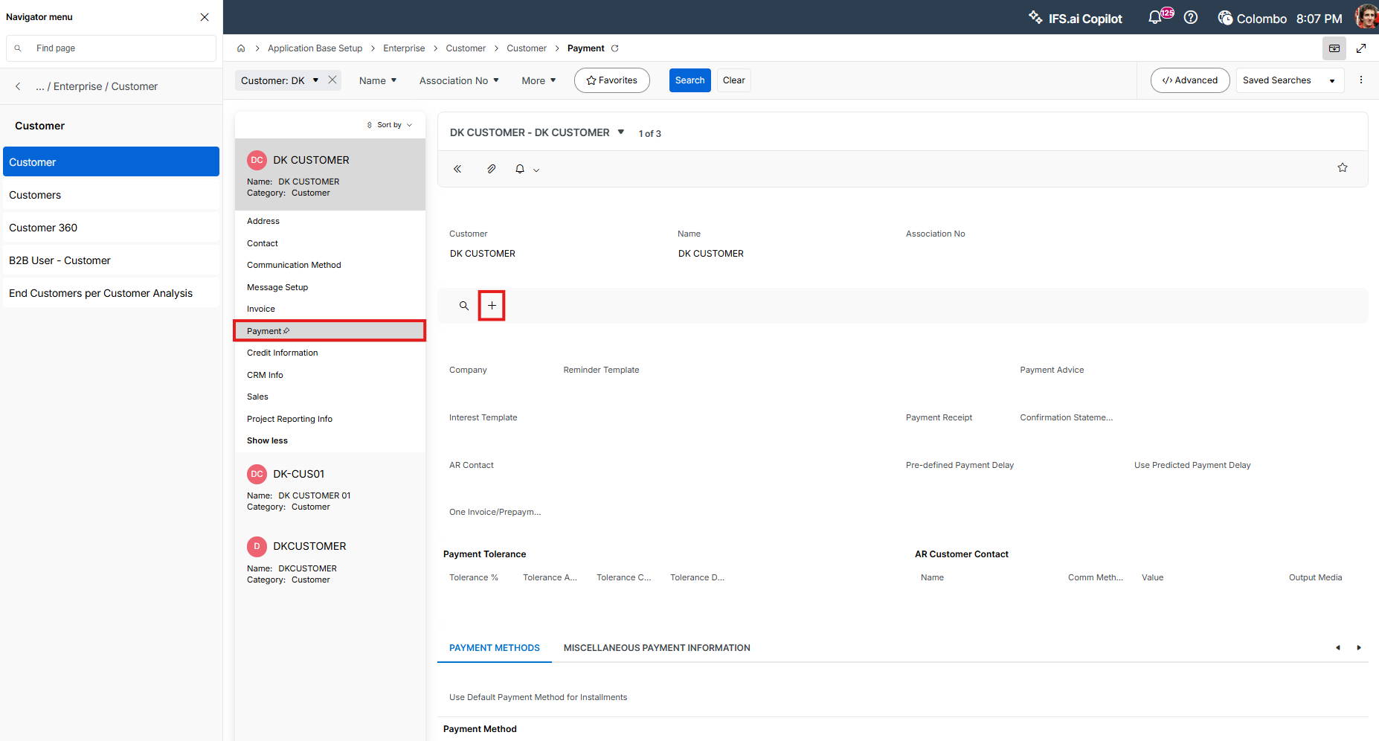

- Add the company and save

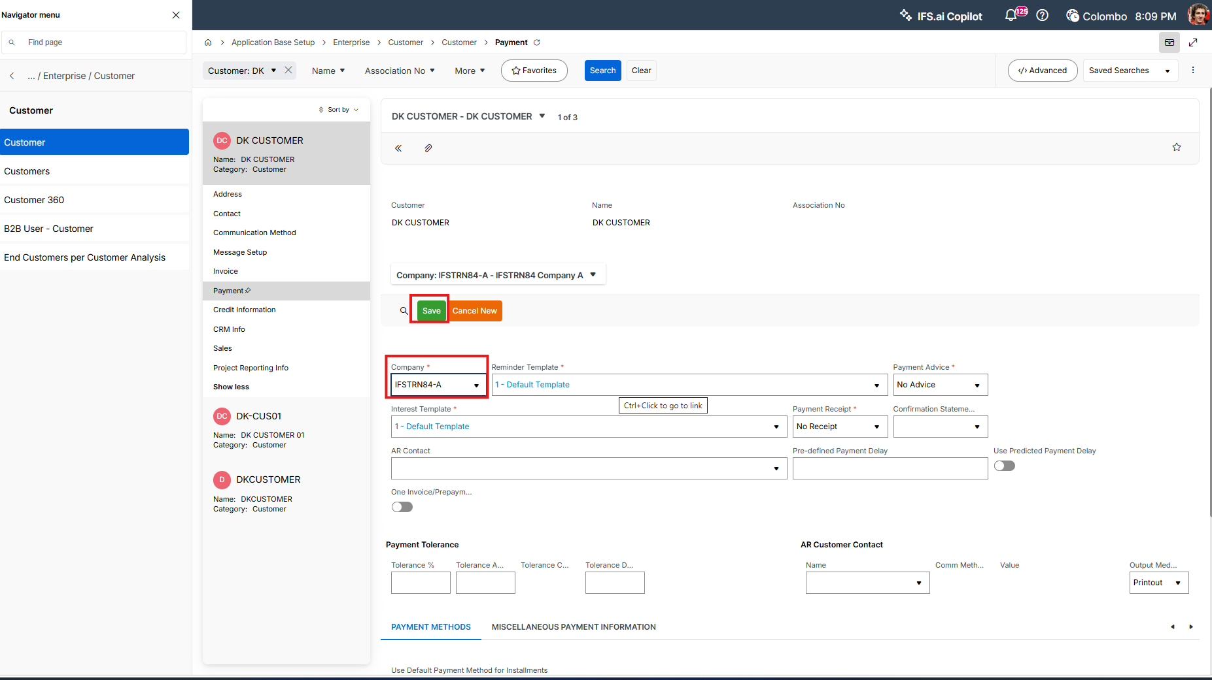
- Go to Credit Information and click on new

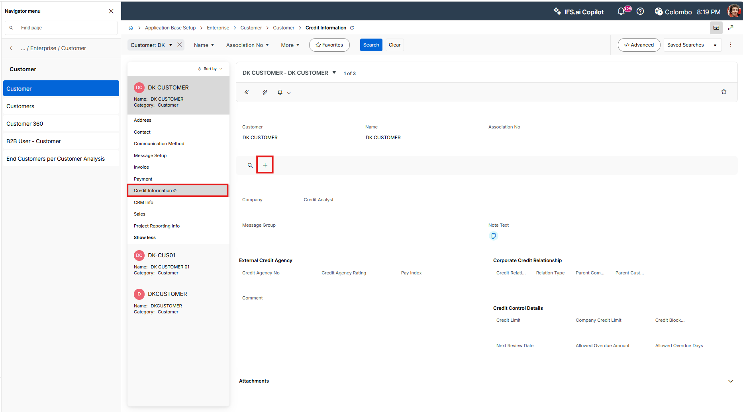

- Add the Company and save

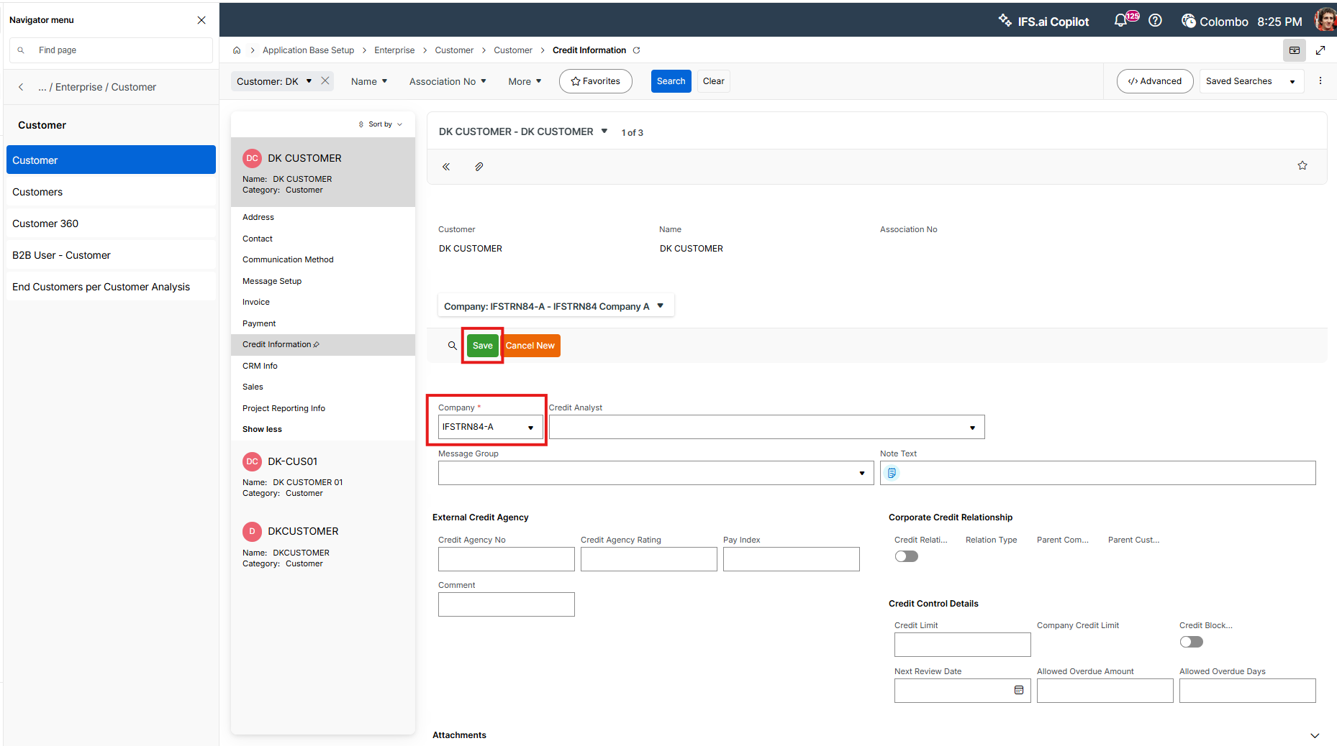
- Go to Sales tab and click new

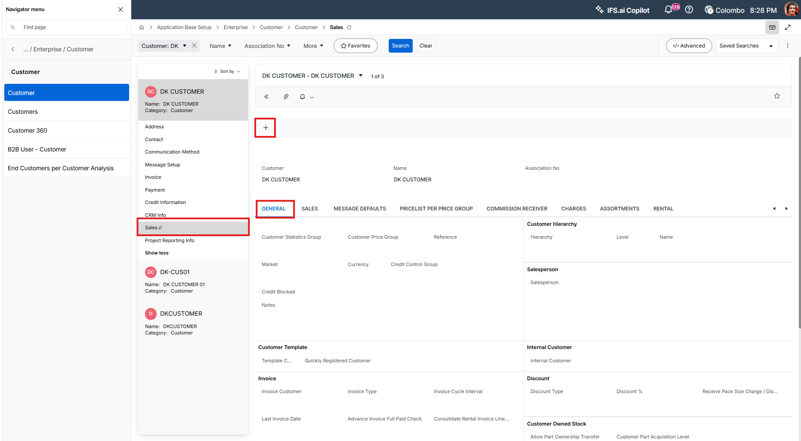

- Add Customer Statistic Group and currency and save

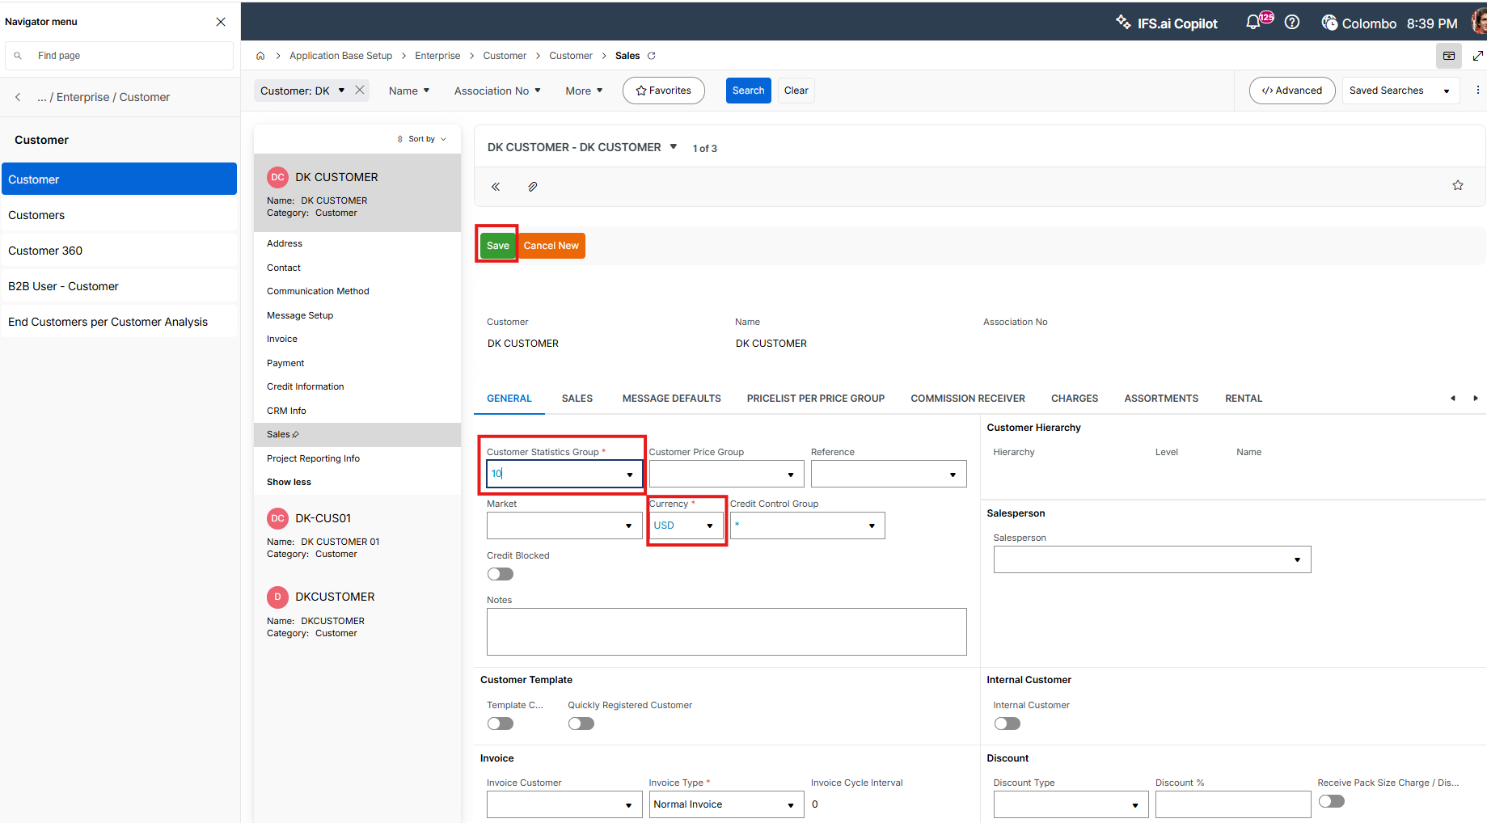

- Go to Sales subtab and add an Order Type

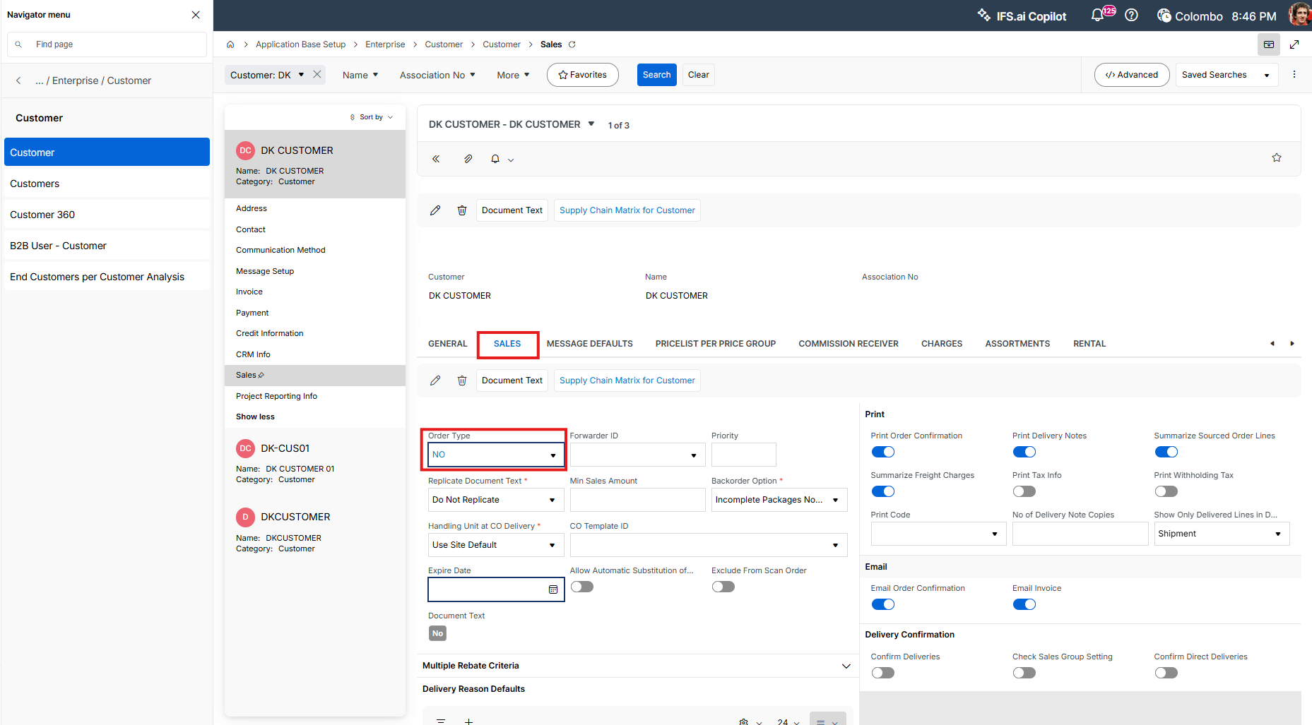

Supplier

Add below data
- Supplier

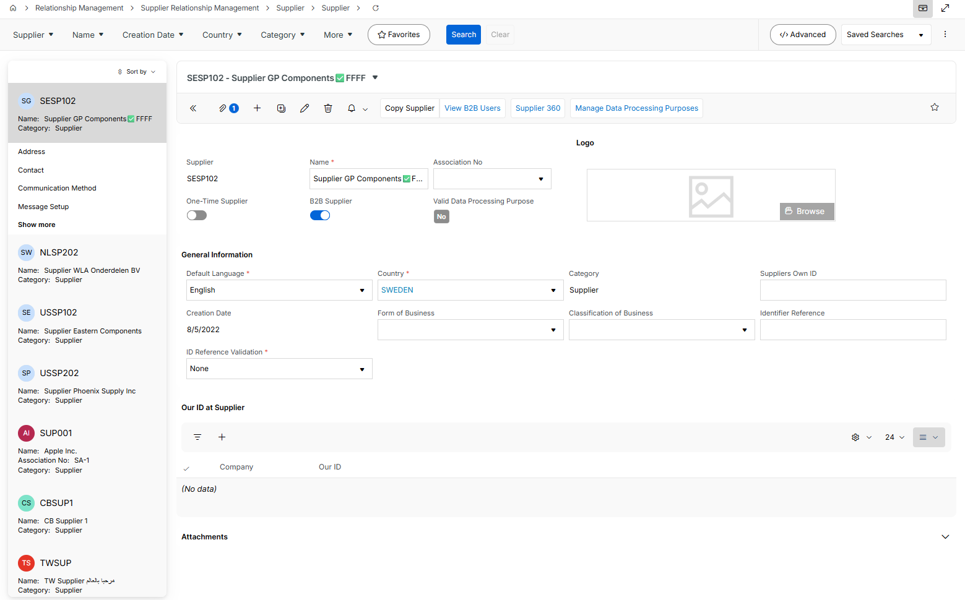

- Address tab

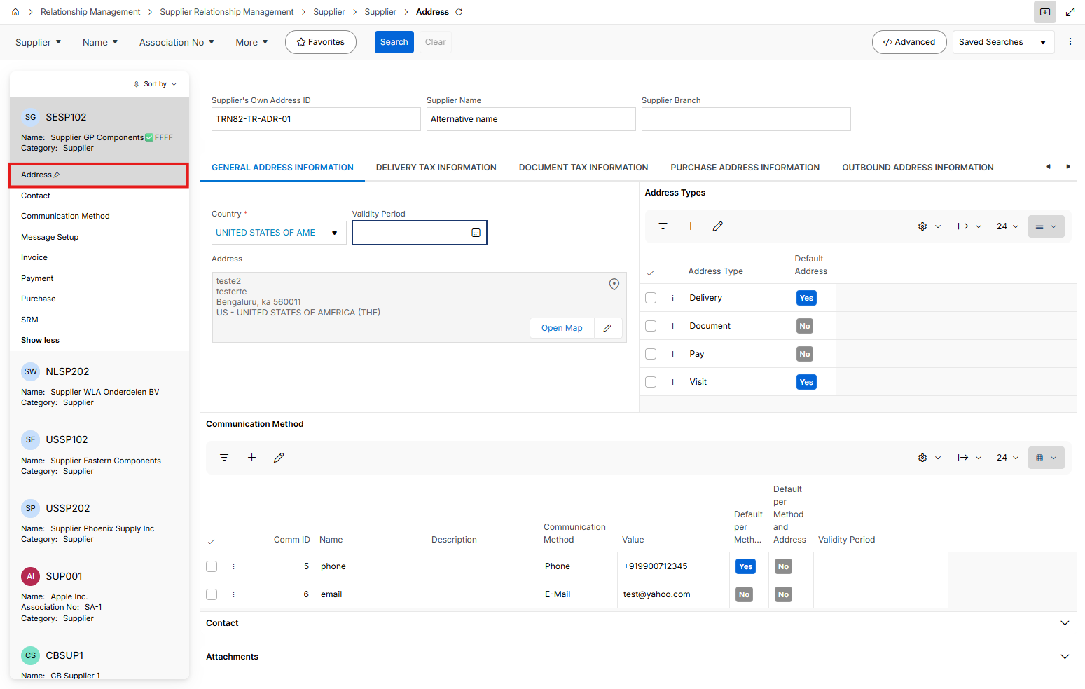

  - General Address Information sub tab

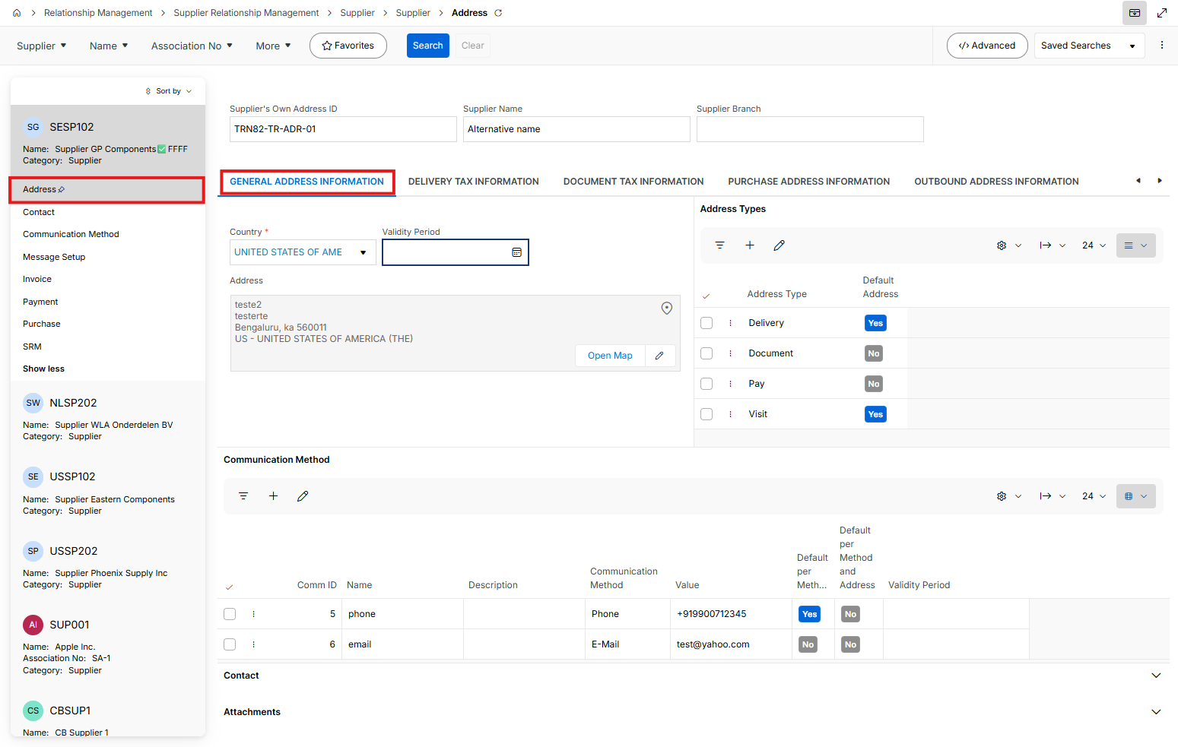

  - Delivery Tax Information sub tab

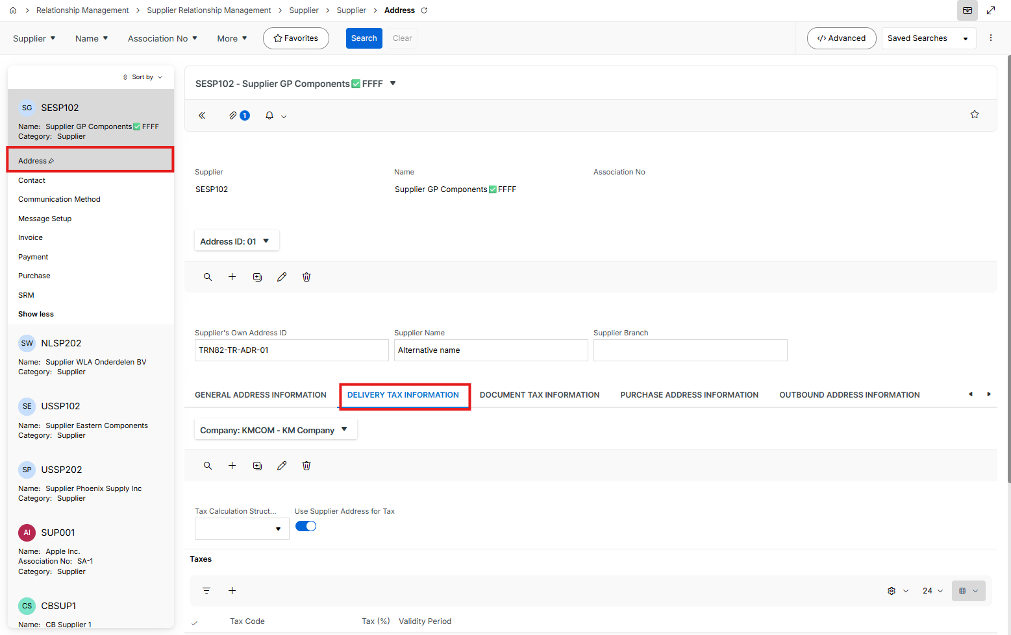

  - Document Tax Information sub tab

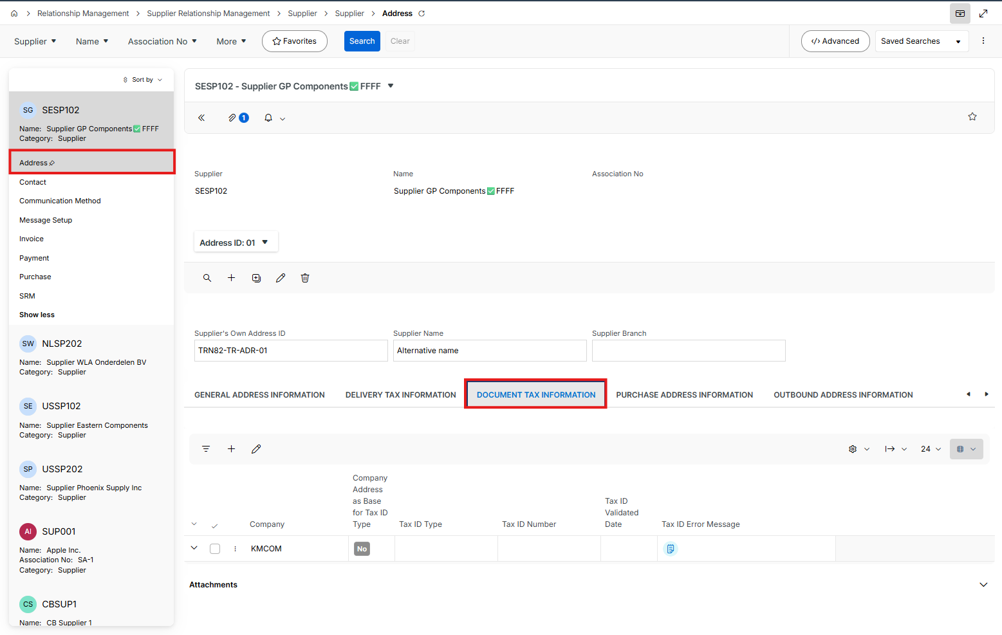

  - Purchase Address Information sub tab

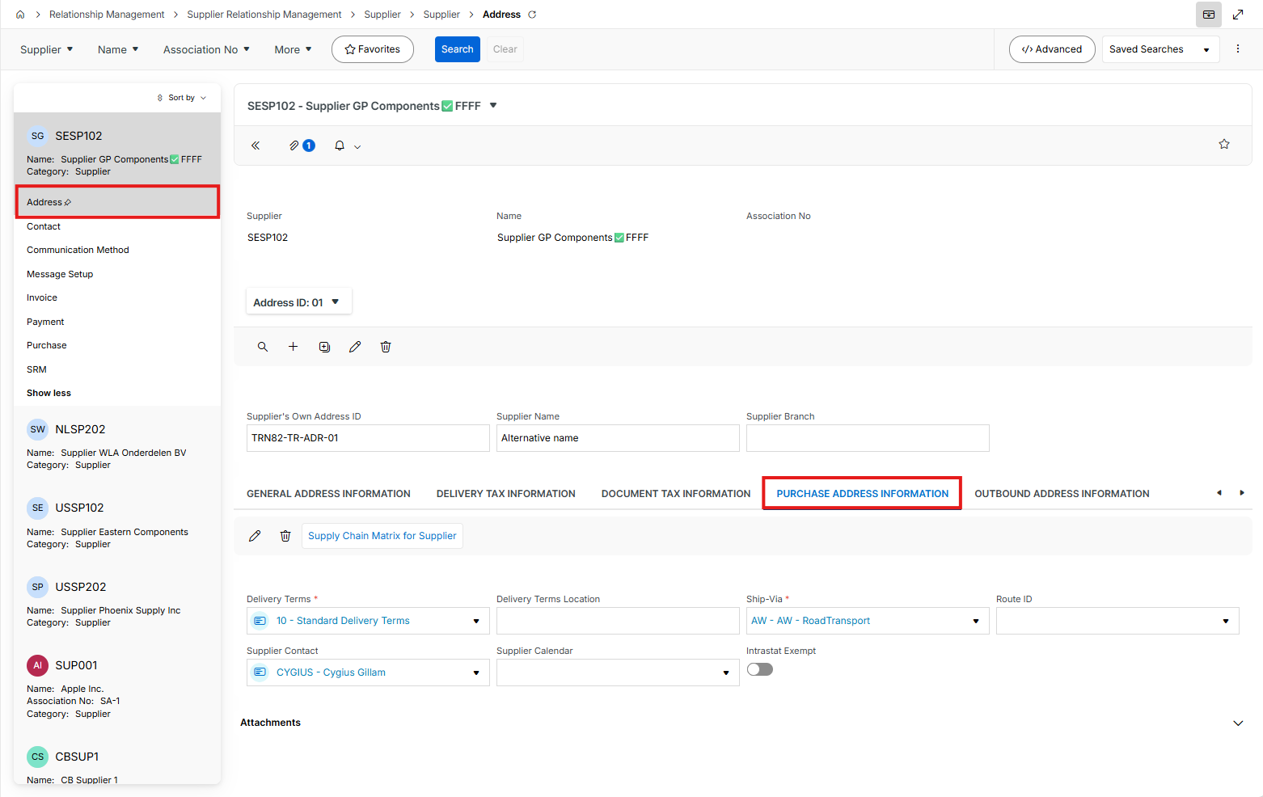

  - Outbound Address Information sub tab

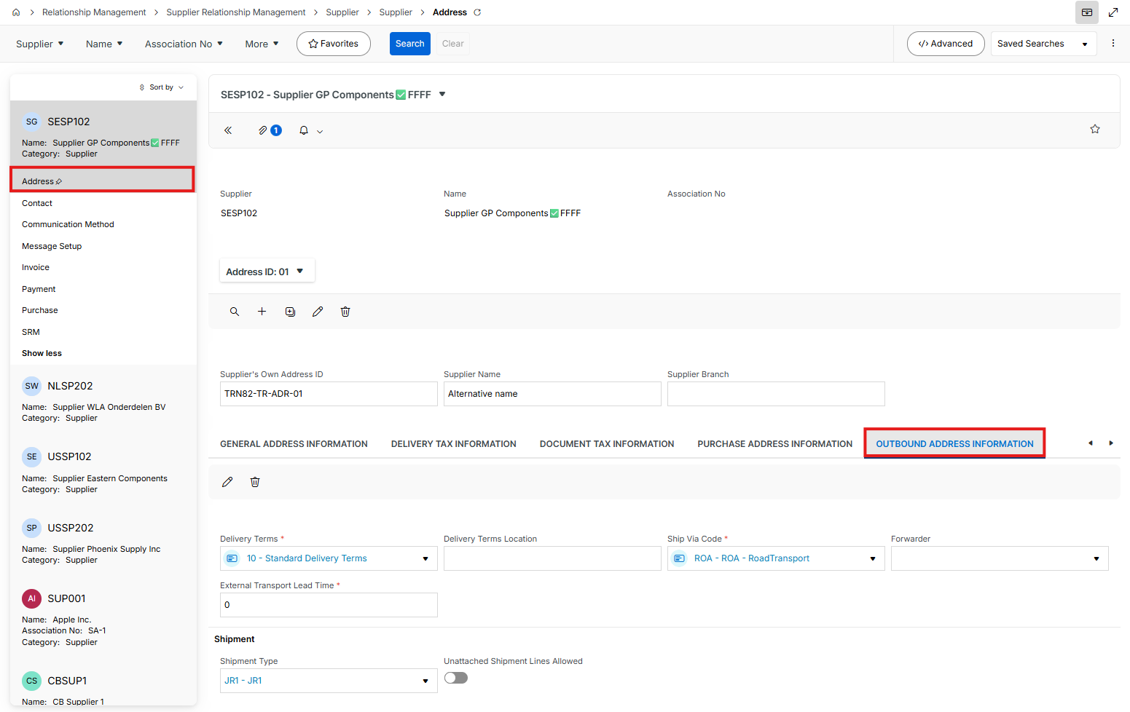

- Message Setup tab

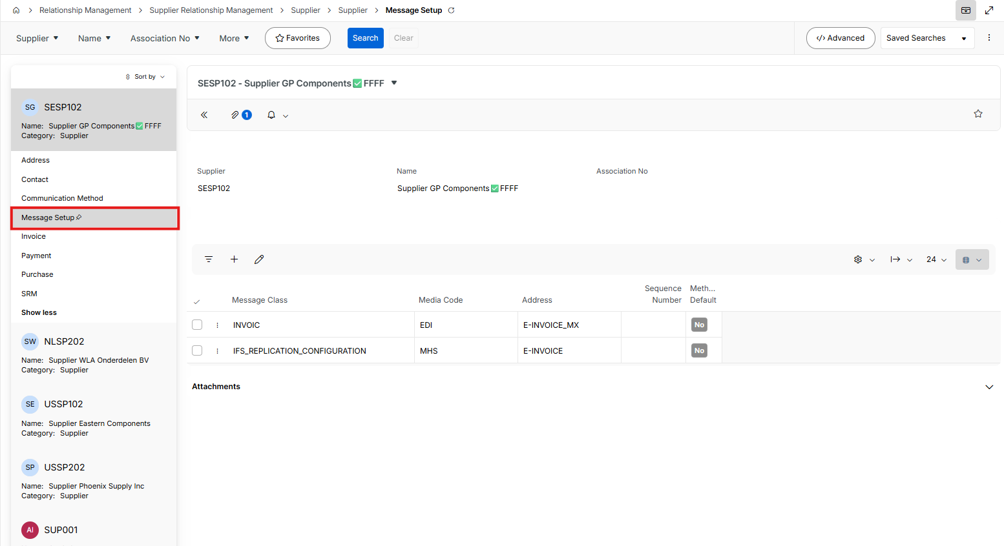
- Invoice tab > General sub tab

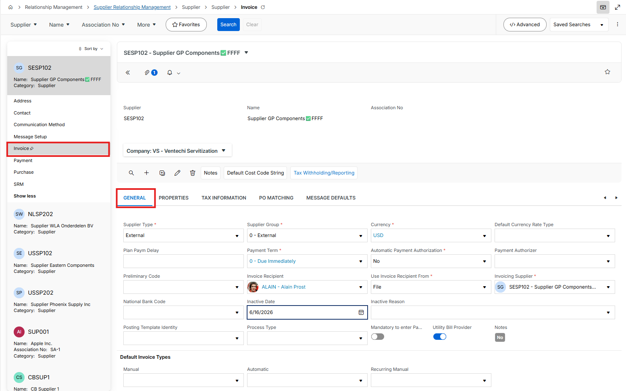

- Payment tab

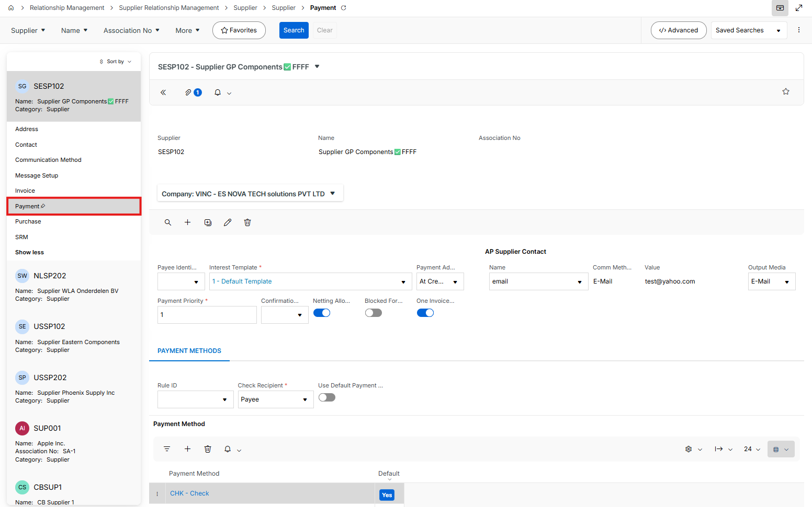
- Purchase tab
  - General sub tab

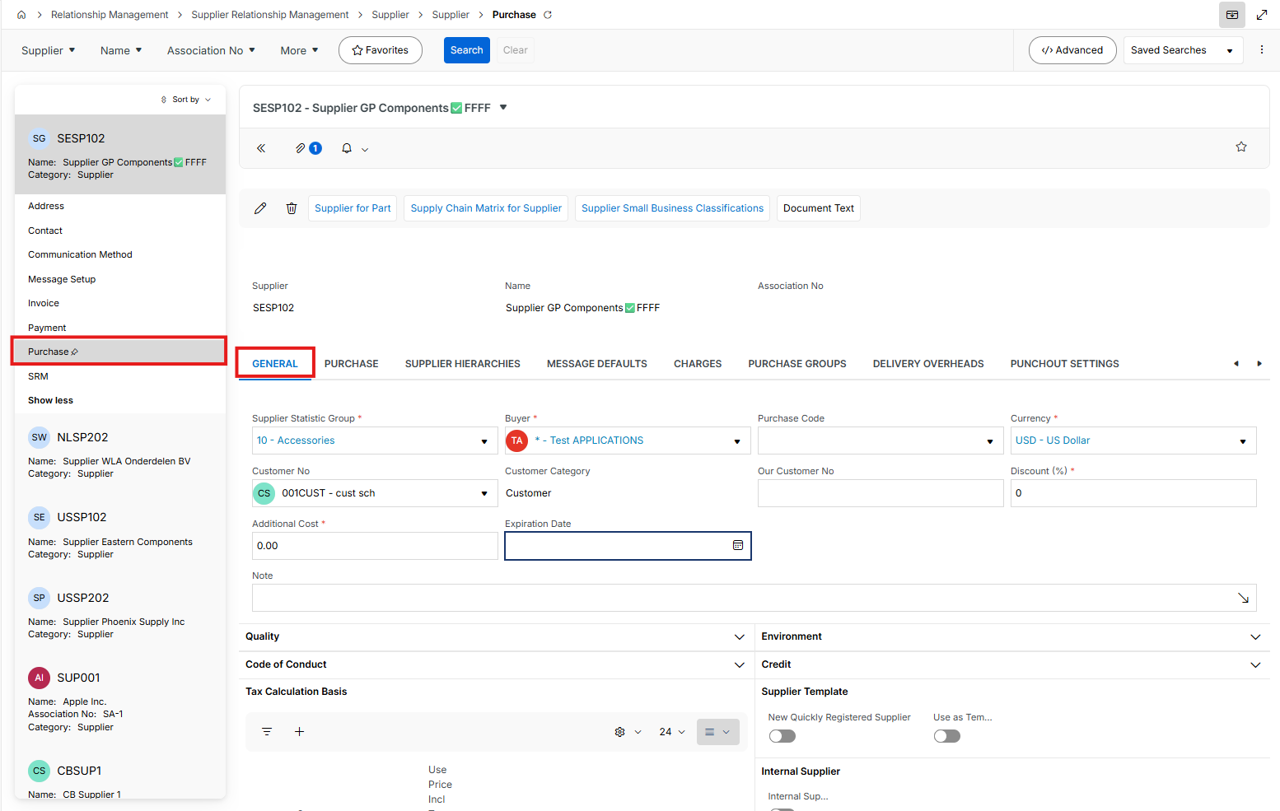
  - Purchase sub tab

Part
- Go to Part page and click new

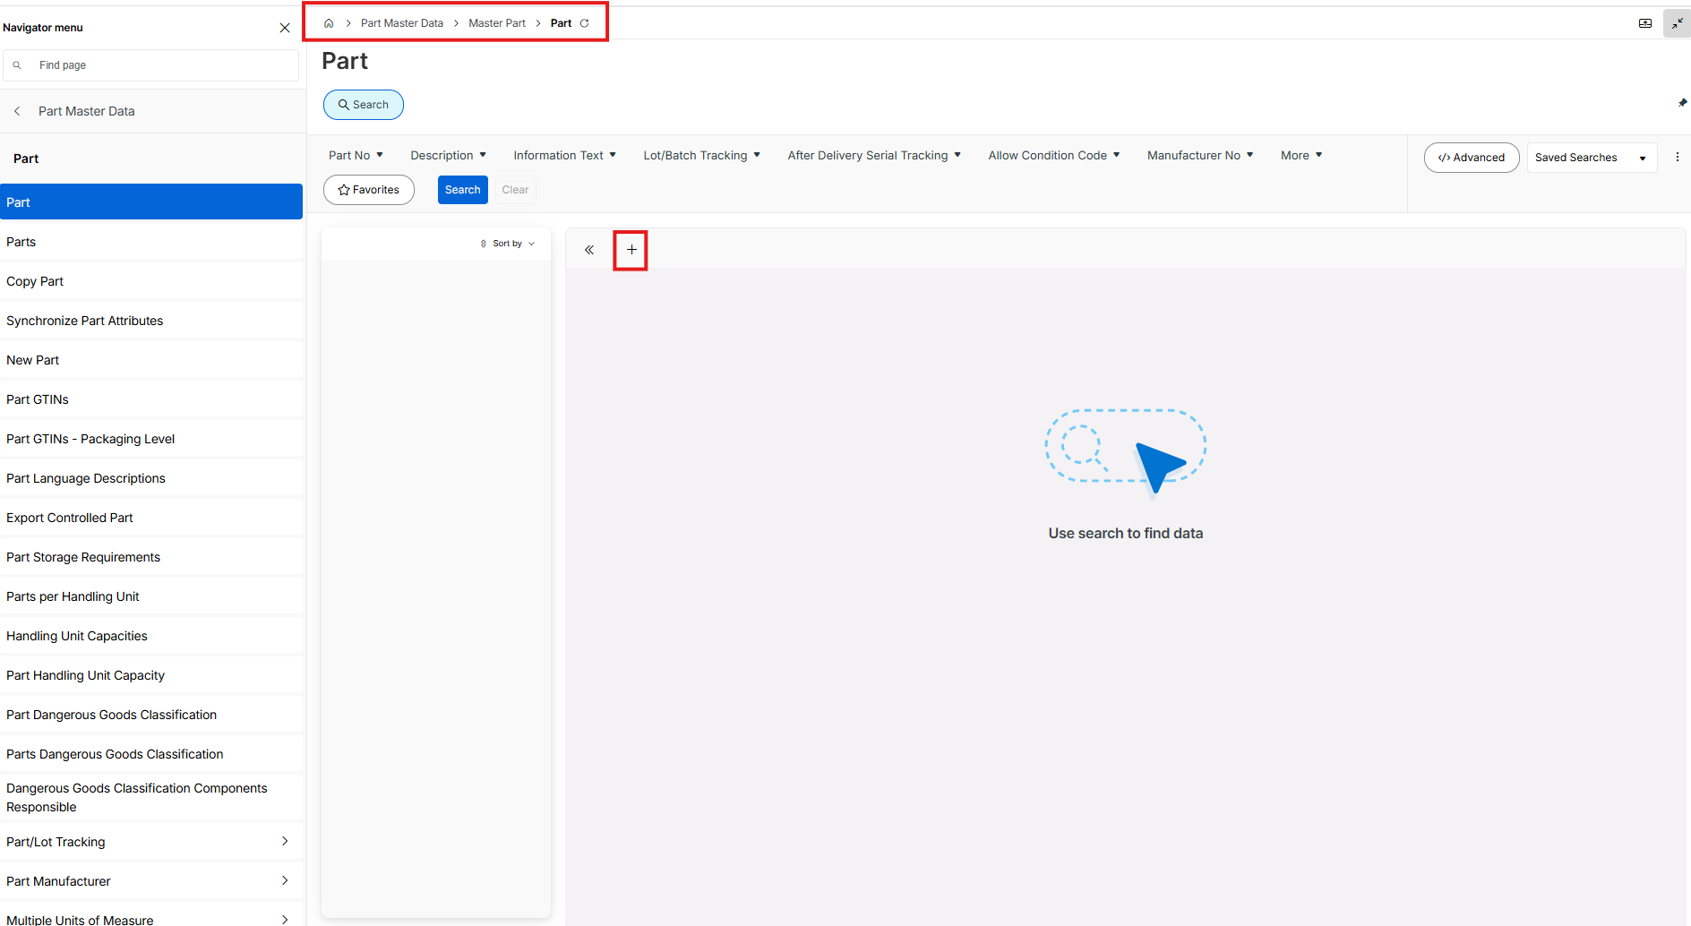

- Add a Part No, Description and UoM
- Save the record

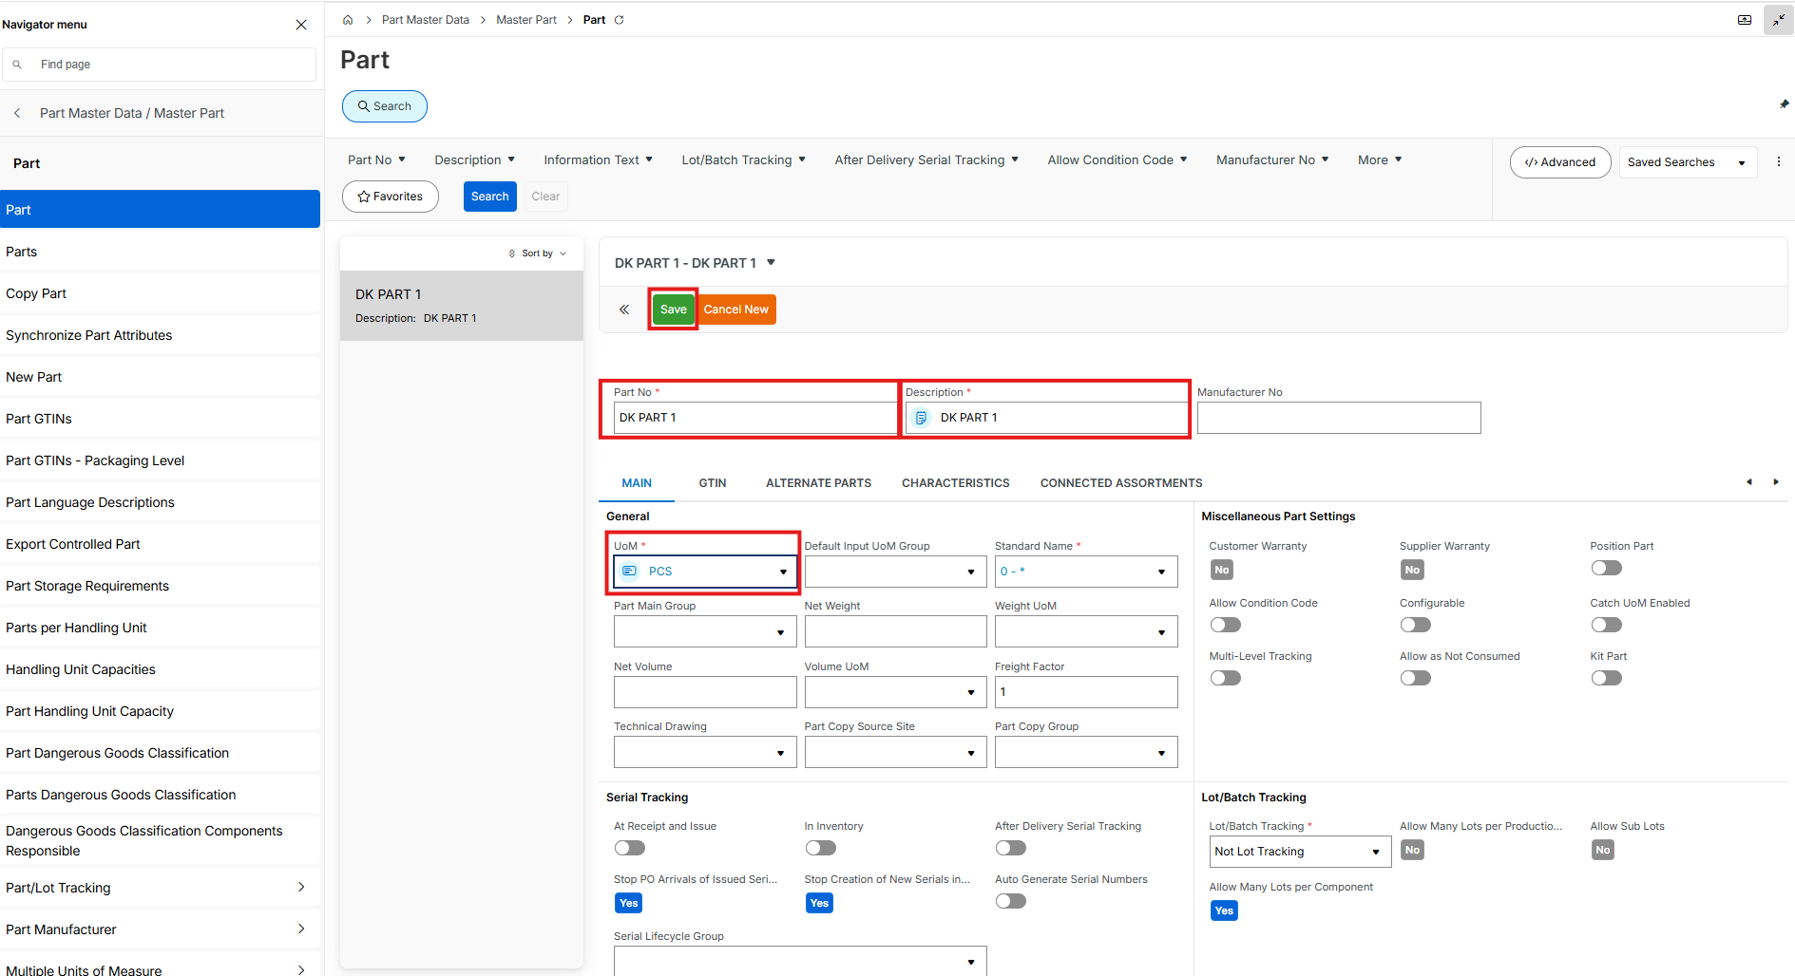

Inventory Part
- Go to Part page and click new

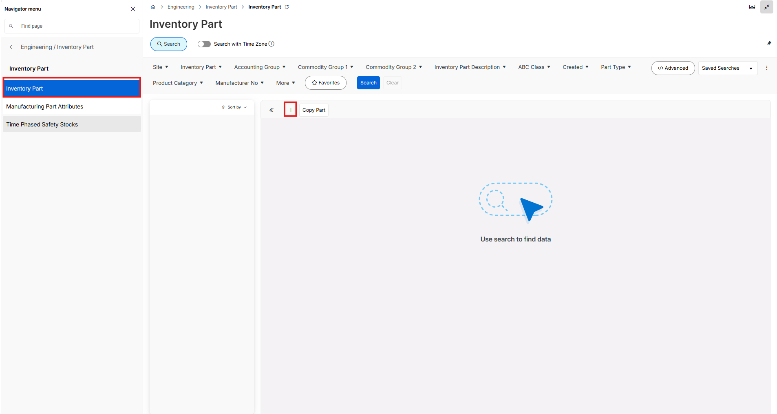

- Add a Part details and the site and data in the Main tab

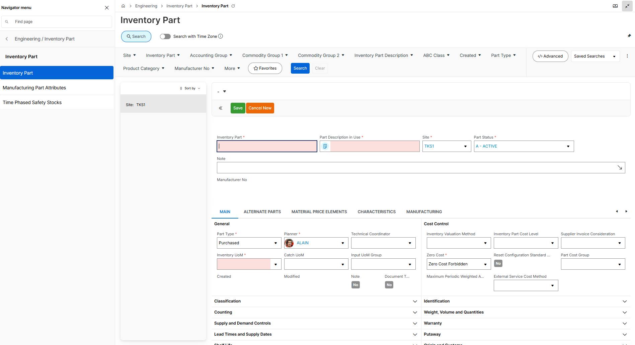

Purchase Part

Add part details, site and the data in the General tab

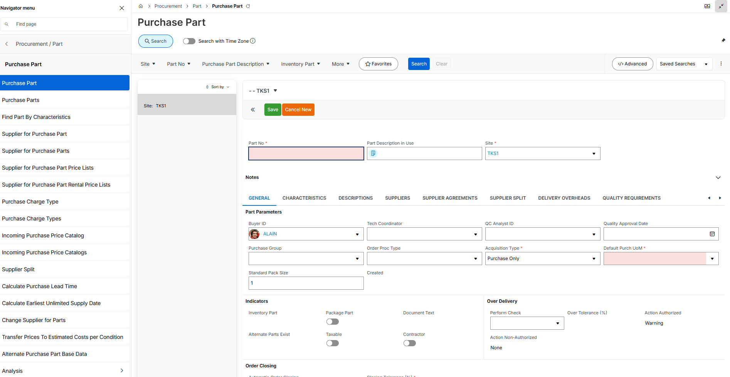

Supplier for Purchase Part

Add part details, Supplier, site and the data in the General tab

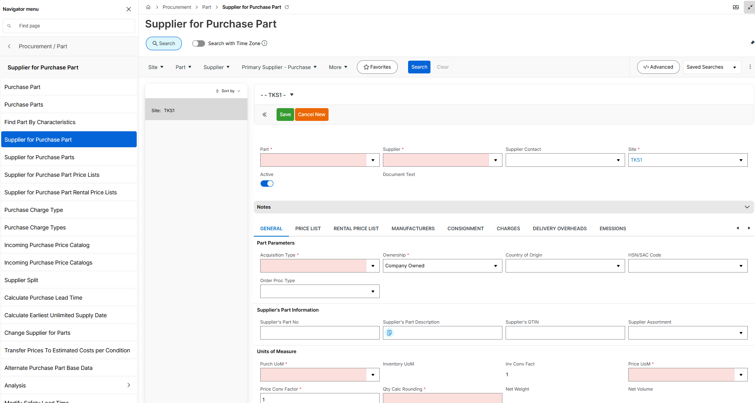

Sales Part

- Go to Sales Part page and Click new

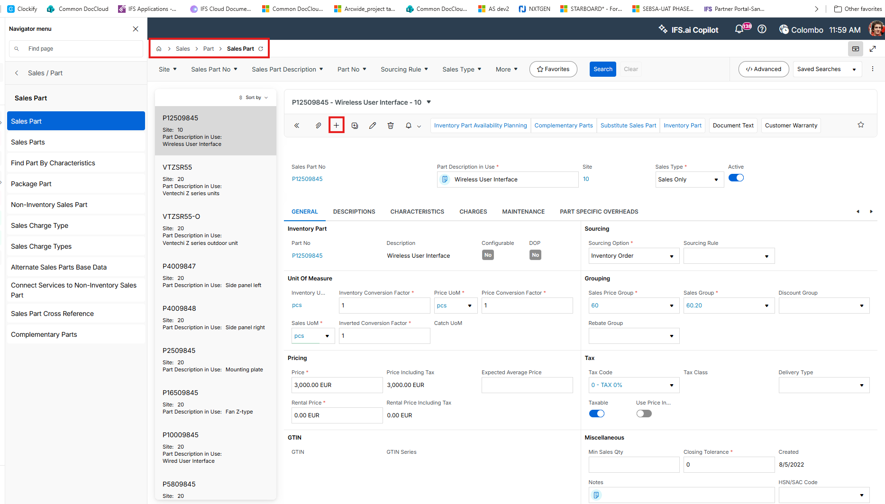

- Add a Sales Part No, Part Description in use, Site, Inventory UoM, Sales Price Group, Sales Group and a Price
- Save

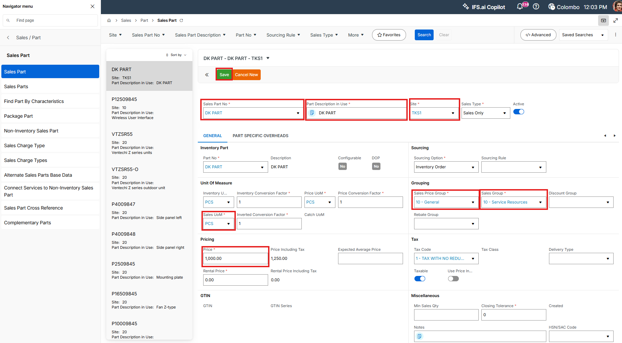

Location Type

Add all details

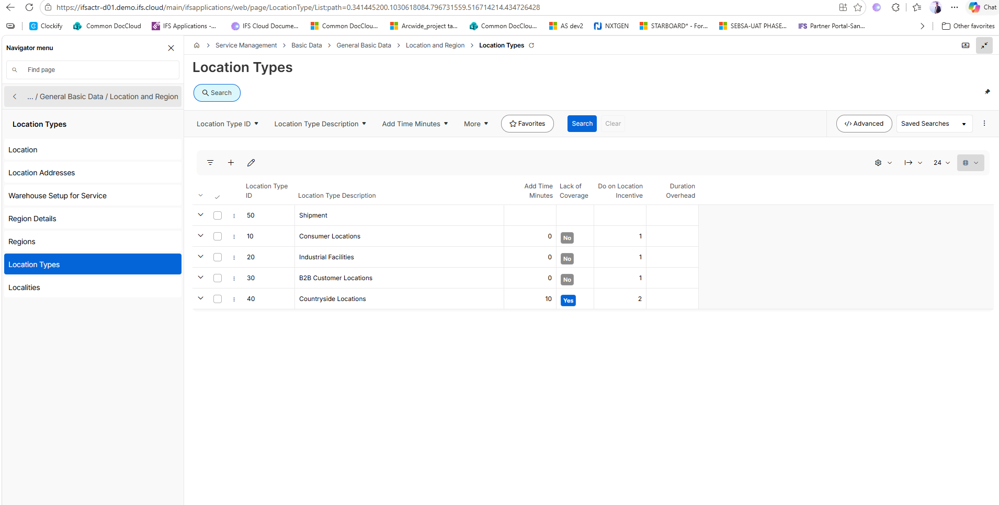

Inventory Location Groups

Add all details

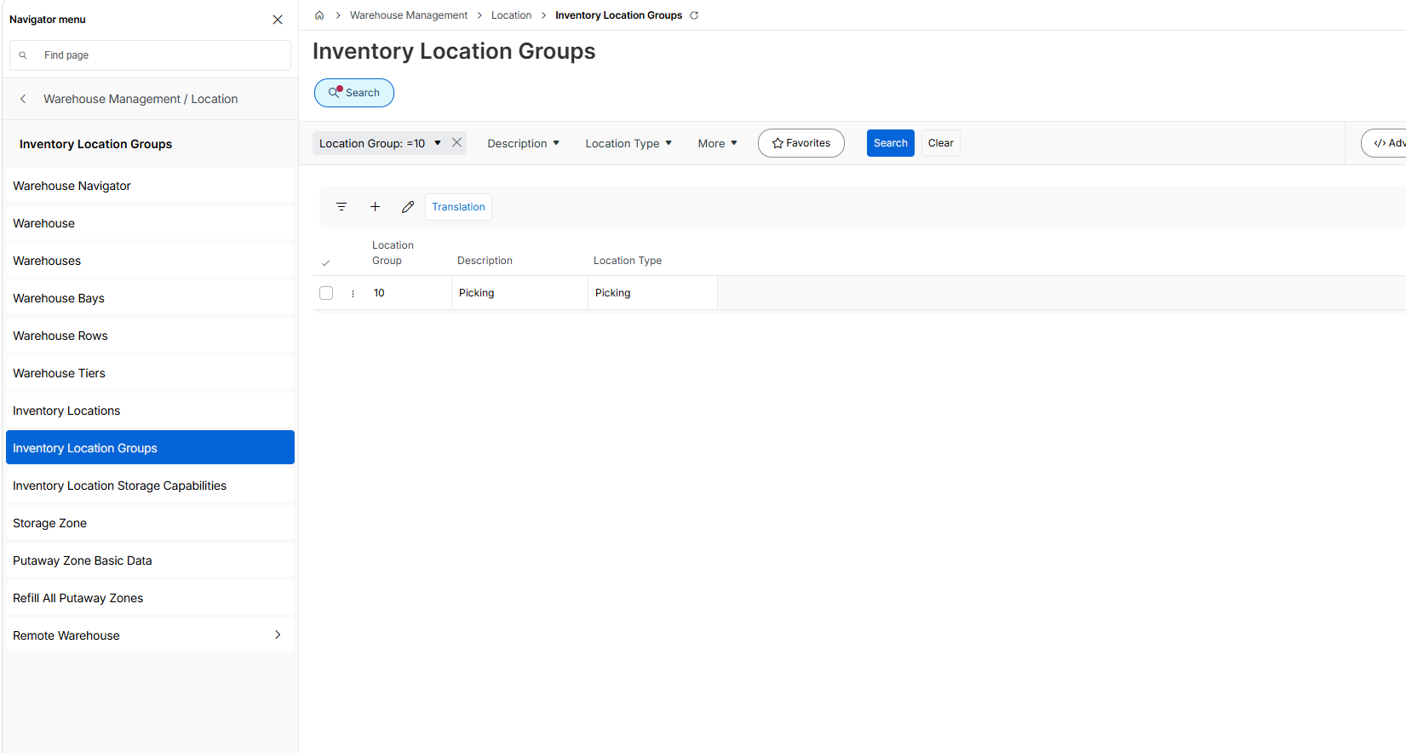

Inventory Locations

Add all fields

